STUDENT PROFILE #1
STUDENT SPOTLIGHT – MEET JENNIFER MOY
Posted on November 20, 2019 by Christopher Larson
Originally from the Bronx, at the age of fourteen, Jennifer and her family moved to Brooklyn, NY. Jennifer had attended Frank McCourt High School, a small school located on the Upper West Side of Manhattan. Her long commute to school presented an opportunity to see the city in new ways. Gazing up at the monoliths, she was awe-inspired by the architecture and structures that surrounded her.
When it came time to decide which college to attend, Jennifer was undecided between City College and Stony Brook University – she had already been accepted into the City College Engineering program. Despite this, Jennifer chose Stony Brook University as her new home. In truth she did not want to attend college in the city, plus the adventure of dormitory living was far more appealing.
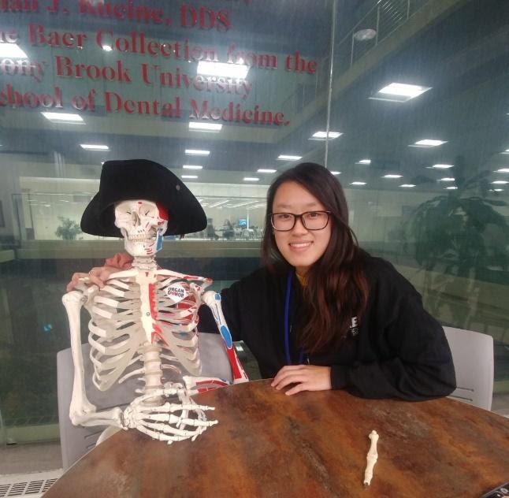
Jennifer started her first semester at Stony Brook University during the summer of 2017 through the Educational Opportunity Program (EOP). In her freshman year her major remained undeclared, but the following year she chose Civil Engineering. In her first year, Jennifer got a job at the Health Sciences Library. Since that time, she has seen some really wonderful changes at the library, and has helped make them happen.
Jennifer is ready to graduate with her bachelor’s degree by May 2021 and wants to specialize in structural engineering: “I grew up in a city full of towers and skyscrapers and it fascinates me how beautiful these structures are, and it inspires and motivates me to contribute to the structural architecture of a city building someday.” We’re looking forward to that day Jennifer!
cc licensed BY-NC https://library.stonybrook.edu/2019/11/20/student-spotlight-meet-jennifer-moy/

