Grossmont College
Governance and Decision-Making Handbook

A Guide to the Recommendation- and Decision-Making Process
Prepared by Governance Organization Steering Committee
8-27-2018

Table of Contents
INTRODUCTION 4
History 6
PHILOSOPHY AND GUIDING PRINCIPLES 8
RULES, TOOLS AND ROLES 9
Meeting Rules of Engagement 9
Meeting Management Tools 10
Consensus Forming and Decision Making 10
Participatory Governance Roles 11
Role of the Convener* and Co-Chairs 11
Role of the Voting Council/Committee Member 11
Role of the Constituency Member 12
Role of the Proxy Member 12
Role of the Expert/Ex Officio Member 13
Role of the Advisory Member 13
Role of the Note Taker 13
Role of the Meeting Guest 13
COMMUNICATION AND DOCUMENTATION 14
GOVERNANCE RELATIONSHIPS 15
Students 15
Classified Professionals 16
Faculty 16
Supervisors/administrators 17
GLOSSARY 18
GOVERNANCE MODEL 20
College Council 20
Purpose 20
Responsibilities 20
Membership 21
Meeting Schedule 22
Quorum: 22
Consensus 22
Proxies 22
Standing Committees 23
Budget Committee 23
Purpose 23
Membership 24
Meeting Dates 24
Link to agendas and minutes: 24
Accreditation Standard 24
Technology Committee 25
Purpose 25
Responsibilities 25
Membership 26
Meeting Dates 26
Link to agendas and minutes: 26
Accreditation Standard 26
Facilities Committee 27
Purpose 27
Responsibilities 27
Membership 27
Meeting Dates 28
Link to agendas and minutes: 28
Accreditation Standard 28
Student Success and Equity Committee 29
Purpose 29
Responsibilities 29
Membership 29
Meeting Dates 30
Link to agendas and minutes: 30
Accreditation Standard 30
Planning and Institutional Effectiveness Committee 31
Purpose 31
Responsibilities 31
Membership 31
Meeting Dates 32
Link to agendas and minutes: 32
Accreditation Standard 32
Professional Development Committee 33
Purpose 33
Responsibilities 33
Membership 33
Meeting Dates 34
Link to agendas and minutes: 34
Accreditation Standard 34
Staffing Committee 35
Purpose 35
Responsibilities 35
Membership 35
Meeting Dates 35
Link to agendas and minutes: 36
Accreditation Standard 36
OPERATIONAL COMMITTEES 37
Student Representation 37
Types of operational bodies 38
Council 38
Committee 38
Steering Committee 38
Advisory Committee 38
Ad Hoc/Task Force 38
Work Group 39
Operational Committees 39
Academic Affairs 39
Administrative Services 39
Student Services 39
Collegewide/President's Office 40
APPENDICES 41

INTRODUCTION
Grossmont College strives to enhance student success, improve the student experience, and ensure equitable access and outcomes for all students. An effective participatory governance will support these outcomes and will create a trustworthy recommendation-making process that the college president can rely upon to guide his or her decision on a broad range of policy development, resource allocations, and plans.
This handbook is designed to clarify the role of staff, faculty, students, and supervisors/administrators in participatory governance at Grossmont College. It provides guidance on the roles and responsibilities of all members of the college community, whether one is serving on a governance body or not. It also serves as a source of institutional memory as it relates to Grossmont College’s participatory governance structure, and the reasoning behind its restructure during the 2017-2018 and 2018-2019 academic years.
This handbook also describes the college’s participatory governance structure, including its bodies, how they relate to each other, and how recommendations flow from one body to the next. It also describes the recommendation- and decision-making process, and how members of college constituency groups and governance bodies participate in that process.
As a foundational framework, this handbook relies on AB 1725, the landmark California legislation that first directed participatory governance activities at community colleges statewide; accrediting standards set forth by Accrediting Commission for Community and Junior Colleges (ACCJC); California education code; California Code of Regulations, specifically Title 5 regulations; and policies and procedures established by the Grossmont-Cuyamaca Community College District governing board (see appendix).
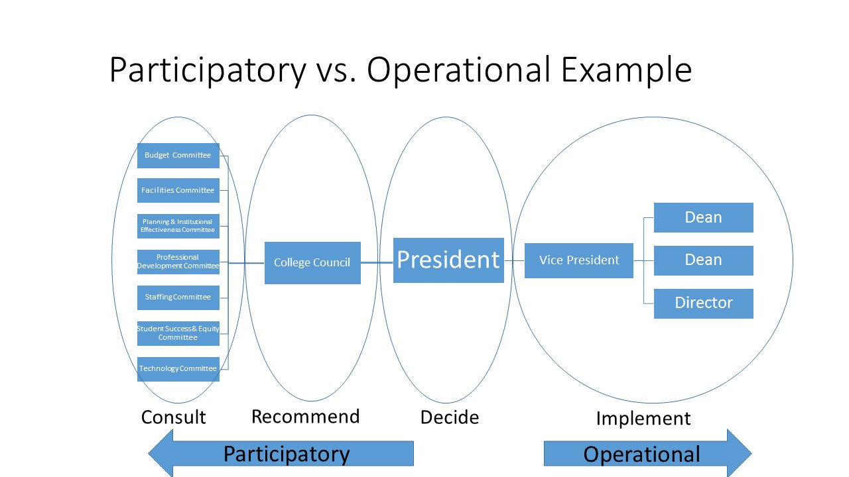
This document focuses ONLY on participatory governance and acknowledges other governance entities and decision-making processes with which participatory governance must engage separately and harmoniously:
- the Academic Senate with rights and responsibilities delineated in AB1725 and reflected in District Board policy;
- the Classified Senate representing the voice of classified staff;
- the Administrator's Association representing the voice of classified and educational managers and supervisors;
- the Associated Students of Grossmont College representing the voice of students;
- collective bargaining laws and the negotiated agreements between the respective employee bargaining units and the Grossmont-Cuyamaca Community College District which deal with matters pertaining to hours, wages, and working conditions and are not addressed in this publication;
- administrative/operational processes which deal with the day-to-day functioning of the college within established policies and procedures and not included in participatory governance;
- operational committees that ensure effective implementation of decisions and allocations made through participatory governance recommendations or administrative processes; and
- district policies and procedures that govern college operations.

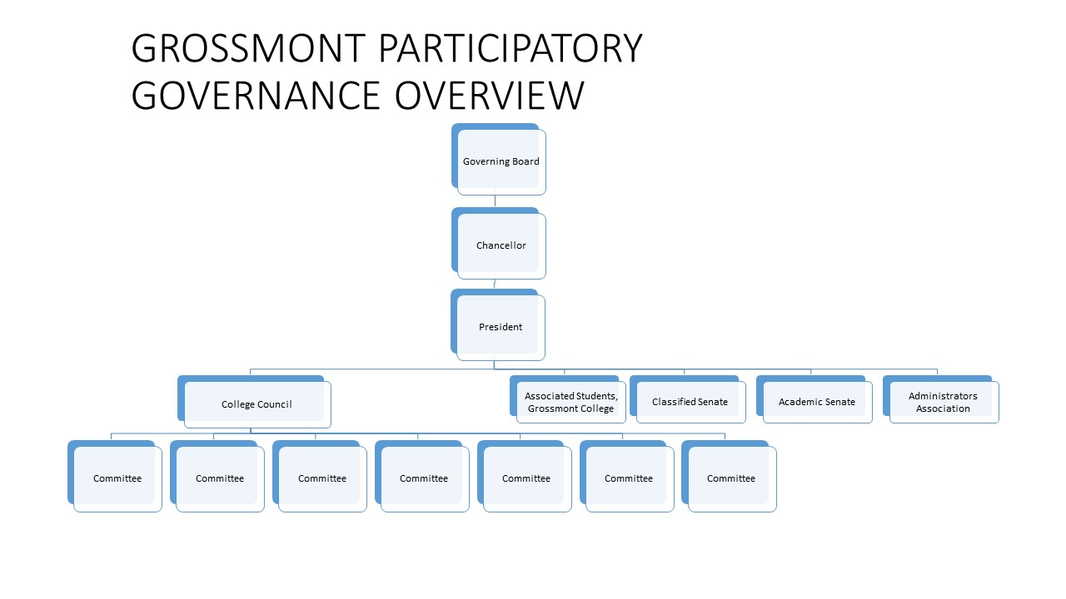The handbook also includes information regarding philosophy and guiding principles; rules, roles, and responsibilities; communication and documentation; and governance relationships. Lastly, there is a dedicated glossary of definitions for phrases and words frequently used in participatory governance settings.

History
In spring 2017, Grossmont College administrative leadership, in coordination with the Academic Senate and Classified Senate, solicited assistance from the California Community Colleges’ Institutional Effectiveness Partnership Initiative (IEPI) regarding three areas of focus: participatory governance, annual unit planning, and assessment of student learning outcomes.
In fall 2017, an IEPI-appointed partnership resource team (PRT) of staff, faculty, and supervisors/administrators from community colleges throughout the state visited with various members of the Grossmont College community and recommended that the college reorganize their participatory governance structure to adhere to the standards of good practice set by the Accrediting Commission for Community and Junior Colleges (ACCJC) in 2014. Specifically, Standard IV addresses:
“The institution recognizes and uses the contributions of leadership throughout the organization for promoting student success, sustaining academic quality, integrity, fiscal stability, and continuous improvement of the institution… Through established governance structures, processes, and practices, the governing board, supervisors/administrators, faculty, staff, and students work together for the good of the institution.”
In fall 2017, it also became apparent to the Accreditation Steering Committee that the college had work to do as it related to Standard IV. A: Decision-Making Roles and Processes. At that time, the Governance Organization Steering Committee (GOSC) was formed, emerging out of the Administration/Senate Officers Committee (ADSOC), and included representatives from various campus constituency groups, including Academic Senate, Administrators' Association, Associated Students of Grossmont College, and Classified Senate, in addition to representatives from the Accreditation Steering Committee and Professional Development. Led by technical assistance providers Helen Benjamin, Ph.D., retired Chancellor of Contra Costa Community College District; and Debbie DiThomas, Ed.D., retired President/Superintendent of Barstow College, the GOSC met numerous times, including several all-day sessions, during the 2017-2018 academic year to begin the work of redesigning the college’s participatory governance structure.
This handbook is the result of that work, and will be continuously updated as it, and the participatory governance structure it describes, evolves over time. It will be reviewed on an annual basis by the College Council and its standing committees, and updated as needed, per ACCJC standards.

PHILOSOPHY AND GUIDING PRINCIPLES

The goal of participatory governance at Grossmont College is to achieve effective participation by all constituencies, where all participants are trained in meeting processes, and collegial and civil behavior is assured. Recommendations are made by consensus, have an equity perspective and focus on student outcomes. By doing so, a decision made by the president will be one that participants can trust was made in full consideration of the opinions expressed by the college's subject matter experts and constituencies.
As a state-funded institution, Grossmont College also has a duty to serve the public good and to be judicious in spending public funds. Effective participation by all constituencies in participatory government serves this purpose by ensuring good planning and transparency.
Effective Participatory Governance at Grossmont College will allow the college the ability to formulate strategic decisions by the active participation of all constituency groups (students, classified professionals, faculty, supervisors/administrators). Governance offers a transparent process by which equity-minded and student-focused decision-making takes place by shared leadership actively seeking consensus on the best way forward with any given issue or opportunity. Through participatory governance, the college is able to maximize institutional effectiveness with a student-focused, equity-based process that creates a culture of participatory and broad leadership. Effective governance requires participation, dialogue, and valued outputs.
- Participation: Constituency representation and active and effective participation in the assigned governance process will ensure Grossmont College will develop and implement policies and practices that produce shared benefit to the college community. The key to successful and effective committee work is active participation by all representatives.
- Dialogue: At Grossmont College, governance dialogue is the process of individuals exchanging ideas through civil discussions designed to achieve mutual understanding. A commitment to equity, civility, mutual respect, and collegial behavior by all participants is essential to achieving consensus.
- Valued Outputs: Governance achieves purpose when the process leads to identification of strategies, solutions, and/or recommendations that advance Grossmont College in the direction of equity-minded, student-centered goals. In this context, "value" is achieved through active participation by constituency representatives in dialogue that produces meaningful consensus and a way forward.

RULES, TOOLS AND ROLES

In order to create valued outcomes, a commitment to participation, dialogue, and the pursuit of value in the form of useful output by all is necessary.

Meeting Rules of Engagement
In participatory government, a high level of collegiality, respect, and civility is expected. Those expectations include the following rules:
- There is no rank in the room when at the committee table. All participants are treated as peers, both between constituencies and within constituencies.
- Speakers will be heard one at a time and without interruption. Participants will allow for moments of silence for thought and other viewpoints. In consideration of hearing all feedback, members should restrict themselves to speaking twice on the same topic, or when emphasizing a point.
- Members will be engaged and contribute, and challenge ideas, not people. All meeting attendees will be respectful/civil in their comments, responses, and body language.
- Members will listen to others, and seek to focus on the merits of what is being said, while making a good faith effort to understand the concerns of others. Council/committee members are encouraged to ask questions of clarification.
- Each person reserves the right to disagree with any proposal and accepts responsibility for offering alternatives that accommodate individual interests and the interests of others.
- All members should be mindful of the language used in discussions, including use of "I" statements instead of "they" attributions to relate anecdotal evidence or experiences. Members are encouraged to use an asset-minded approach that focuses on what works and how something can be done. This is in contrast to a deficit-minded approach that focuses on the negative and why an initiative, idea, or project can't get done.
- All council/committee members will be aware of which issues are under the purview of the committee. When issues arise in discussion that are not supported by the committee’s charge, members should stop discussion and forward the issue to the proper council, committee, or constituency group leadership for consideration.
- Once a decision is made after deliberation, council/committee members will support the group's decision. The time for individual comment is during the meeting; all actions are taken as a group.

Meeting Management Tools
Tools in this section address how the governance meeting should be organized, a simple process of for how to apply consensus decision-making to meeting deliberations, the roles of chair-persons and participants, and strategies for effective record-keeping and communications.
Meetings are the primary mechanism for convening governance groups. Effective meetings require well-thought-out agendas, active participation, and a record of the meetings, topics and outcomes. Best practices for agenda design include the following:
- Careful agenda preparation in advance, using provided templates that are both easily found online and in print, and are ADA-compliant for accessibility
  - Remember, agendas are driven by committee charge
- Focus on prioritized issues
  - Items included are prioritized based on the committee charge
  - Items should also be prioritized based on time of occurrence in the academic year
- Balance between agenda items and meeting time available
  - A thoughtful balance between presentation and discussion should be maintained
  - Remember: a one-hour meeting should have no more than two agenda items requiring active dialogue
- Discussion content should be “framed” by well-designed questions
  - Providing questions for discussion can invite focused participatory input better than simply framing content by topic
- Record key findings and commitments using accessible meeting notes templates

Consensus Forming and Decision Making
Achieving meaningful consensus is essential to effective governance and leads to the formation of decisions that advance the college community in the direction of preferred outcomes. In this context “consensus” describes a general state of agreement rather than a “majority opinion.” Clear agreements and public indications of understanding and support by committee members are critical to maintain forward progress of all governance groups. Participatory governance is driven by dialogue addressing issues of shared importance that seeks consensus. All council/committee members, especially the chair or convener, are expected to make good-will attempts to resolve each participant’s concerns before asking for agreement and closing discussion regarding a recommendation or forward actions.
At Grossmont College, consensus is reached on the College Council and on standing committees when at least three-fourths/75 percent of voting members present are in agreement on a decision. Consensus is not reached on College Council if more than two of those in the minority are members of the same constituency; this does not apply to standing committees. In those instances when consensus is not reached, more conversation is required and the item may not move forward as a recommendation.
Recommendations are forwarded from standing committees to College Council, and from College Council to the College President. The College President is responsible for a final decision and is expected to provide to the College Council a written response that includes his/her reasoning regarding that decision, especially if the decision departs from the recommendation.
Participatory Governance Roles
There are several roles for those who participate in a participatory governance body. The following list describes those roles and the expectations for each type.

Role of the Convener* and Co-Chairs
The role of the convener of College Council, or the co-chairs of any standing committee, is important in managing the business of that participatory governance body. (*For the College Council, the person convening the meeting is a convener due to their lack of voting on that body.) For meetings, the convener or co-chairs are responsible for:
- developing agendas, including awareness of the college's calendar and the scheduling of items to ensure timely discussion and processing in the participatory governance system, especially in those instances where items must be forwarded to the district governing board for approval;
- ensuring members attend meetings regularly and following up with constituency leadership regarding any chronic absenteeism;
- ensuring meeting discussions are focused on agenda items that adhere to the committee/council’s charge;
- participating in convener/chair training;
- ensuring meetings adhere to the Brown Act; and
- equally collaborating with their committee co-chair on the aforementioned items.

The College Council convener and committee co-chairs are also responsible for ensuring that all members are properly trained, and for requesting appointment or reappointment of constituency representatives. Most importantly the convener and co-chairs are responsible for ensuring all committee members have an opportunity to voice their opinions and ideas, and cultivating a safe and welcoming environment for discussion.

Role of the Voting Council/Committee Member
Participatory governance works best when all participants approach their role with a goal of understanding the committee’s purpose and objectives, contributing ideas, listening for understanding, and are committed to equity, civility, mutual respect, and collegial behavior.
Active participation by all committee members enables the college community to strive for governance outcomes that are inclusive, reflect all constituency perspectives, and expand the leadership capacity of Grossmont College. Participants should be consensus-seeking rather than position-taking, which requires the dialogue process to be transparent and enables all members to both listen and understand one another clearly. Committee members should come to meetings on time and prepared, having read, reviewed any materials provided in advance and/or having completed any assigned tasks.
While the college's participatory governance system does not specifically record votes, recommendations are made by standing committees and the College Council through informal voting that results in consensus. All council and committee members, whether voting or not, are able to discuss items under review, but only voting members can participate in voting and providing a formal recommendation.
In the event that a committee member who represents a constituency is absent, the member may appoint a proxy. In those instances, proxy have the same authority to discuss and vote on issues on behalf of the absent member they represent. On College Council, a maximum of two proxy members is allowed for each constituency group at each meeting. It is the responsibility of the constituency group representative to inform the proxy of agenda items, constituency group discussions, and committee/council discussions related to the agenda item, and to notify the convener or co-chairs of their absence and assigned proxy.

Role of the Constituency Member
Constituency members representing students, staff, faculty or supervisors/administrators, have an important role in the participatory governance process. By representing the whole of their constituency, e.g., all faculty, all classified professionals, all students, and all supervisors/administrators (excluding the executive leadership team), bring important viewpoints, experiences, context, and institutional memory to the meeting table.
As a constituency group representative, they are representing the “we” of their group as opposed to themselves as an individual, their respective department or program, or their division. Constituency group representatives are appointed by their respective leadership group – Academic Senate, Administrators' Association, Associated Students of Grossmont College, or Classified Senate – to represent their group and are responsible for reporting back to their groups in addition to creating a two-way communication between participatory governance bodies and their constituency.
There is a maximum of three years of service for each constituency member where they must be reappointed or replaced by their leadership.

Role of the Proxy Member
Proxy representation on committees and councils is arranged by the constituency group representative who will be absent for an upcoming meeting. While there is responsibility for the constituency group representative to inform the proxy member of the committee’s agenda, discussions, and action items, the proxy is responsible for understanding as much as possible regarding the committee/council meeting that they will attend, including proper meeting preparation and coming to the meeting on time.

Role of the Expert/Ex Officio Member
An expert member is appointed to a committee or council because they have an expertise and/or official position relevant to the work of the committee. The role of the expert member is to advise and provide counsel to the committee so that all members may have a thorough understanding of the matter under discussion. Expert/ex officio members are full members and have the right to vote.

Role of the Advisory Member
Similar to the expert/ex officio member, an advisory member is appointed to a committee or council because they have an expertise relevant to the work of the committee. However, they do not have the right to vote on committees or councils.

Role of the Note Taker
Each participatory governance committee or council should have an assigned note taker to record discussions and conclusions, and distribute agenda and meeting minutes in a timely fashion. Note takers will most likely be the administrative assistant for the permanent administrative co-chair. Note takers cannot serve as committee/council members or as proxy and, if absent, the note taker and/or convener or co-chairs should find an appropriate substitute who is not an existing committee member.

Role of the Meeting Guest
Three types of guests may attend participatory governance committee or council meetings:
- guests who provide expert knowledge who have been invited to attend on behalf of the convener, co-chairs or a committee/council member;
- guests who wish to make a statement during open comment; and
- guests who wish to observe the open meeting.
Guests do not have voting privileges and are only allowed to comment upon invitation, such as the agenda item for which they are providing expertise or during open comment. All meeting guests should be respectful, enter and exit the meeting with as little disruption as possible, and limit their comments to the agenda items under discussion, unless they are commenting during open comment.

COMMUNICATION AND DOCUMENTATION

Effective participatory governance depends on good communication and documentation. To be most effective, governance communications and documentation should:
- enable all members of the college community to see, understand and participate in governance activities through use of accessible, ADA-compliant agendas and minutes created from a college-provided template;
- focus on documentation of agreements, actions items, and relevant context for the:
  - participatory governance body
  - between participatory governance bodies, e.g., College Council and standing committees or between standing committees
  - for constituency groups;
- ensure standing committees move recommendations forward to the College Council and that the College Council forwards recommendations to the College President for final consideration and decision-making;
- annually review and evaluate the process via the College Council;
- and provide a feedback mechanism.

Communication and documentation are essential to the active participation of all constituency groups. Best practices for ensuring this result are listed below:
- establishing outcome reporting protocols accessible to all in the community college;
- providing agenda and meeting records in a timely manner;
- providing timely publication of meeting records with clear action items;
- keeping meeting records that reflect key discussion points, outputs, and action items;
- adhering to agenda and minutes publication timelines as a matter of good practice; and
- providing an accessible document repository that is ADA-compliant.

GOVERNANCE RELATIONSHIPS

Grossmont College is led by an executive leadership team comprised of the president and vice presidents. To create an effective recommendation- and decision-making process, the executive leadership team seeks input and feedback from the college’s constituency groups via the participatory governance system. The college’s constituency groups include:
- students, represented by the Associated Students of Grossmont College;
- classified professionals, represented by Classified Senate;
- faculty, represented by Academic Senate; and
- supervisors/administrators, represented by Administrators' Association.

Other representative bodies for college employees include bargaining units such as American Federation of Teachers (AFT), California School Employees Association (CSEA), and Administrators' Association. Administrators' Association is the only group on campus to represent members as a constituency group and as a bargaining unit; it represents educational and classified supervisors and managers districtwide.

Students
Associated Students of Grossmont College (ASGC) is the student government that represents students at Grossmont College, and represents Grossmont College students at the Student Senate for California Community Colleges (SSCCC) at the statewide level. ASGC is comprised of an executive leadership team that includes a president, vice president, vice president of finance and other positions, as well as a board of directors where each director represents 1,000 students.
ASGC makes recommendations to the college regarding academic and curricular concerns, such as those outlined in the California Code of Regulations, Title 5, Section 51023.7, commonly known as "9+1," as having a significant effect on students and calling for student contributions to decision-making:
- Grading policies;
- Codes of student conduct;
- Academic disciplinary policies;
- Curriculum development;
- Courses or programs that should be initiated or discontinued;
- Processes for institutional planning and budget development;
- Standards and policies regarding student preparation and success;
- Student services planning and development;
- Student fees within the authority of the District to adopt; and
- Any other District and college policy, procedure, or related matter that the District governing board determines will have significant effect on students.

Per GCCCD BP 2510:
“The Governing Board recognizes the Associated Students of Grossmont College and the Associated Student Government of Cuyamaca College as the official voices for students in the District. Students, through the Associated Students groups, shall be given an opportunity to participate effectively in the formulation and development of District policies and procedures that have a significant effect on students, as defined by law. The recommendations and positions of the Associated Students will be given every reasonable consideration. The selection of student representatives to serve on District committees or task forces shall be made after consultation with the Associated Students.”

Classified Professionals
Classified staff are represented as a constituency by the Classified Senate at Grossmont College. The Classified Senate represents non-supervisor classified staff employees, including confidential employees. Throughout the district, the Classified Senates promote the interests of all Grossmont-Cuyamaca Community College District Classified Staff in accordance with AB 1725 mandates.
Per GCCCD BP 2510:
“Administrators and staff shall be provided with opportunities to participate in the formulation and development of District policies and procedures that have a significant effect on staff. In the development of policies or procedures, after consultation with the administration of the colleges/District, staff may present their views and recommendations to the Governing Board. The opinions and recommendations of the Confidential Administrators, Administrator’s Association, Classified Senate, California School Employees Association (CSEA), and Confidential Employees will be given every reasonable consideration.”
In addition, the California School Employees Association (CSEA) is the exclusive bargaining agent for classified staff employed by the GCCCD and as such negotiates and represents classified staff in contractual issues. Per the district governing board, the role for CSEA in participatory governance is to select members to serve on governance committees and councils specific to bargaining subjects.

Faculty
As a constituency, faculty are represented by Academic Senate, which consults collegially with both the college administration and the Governing Board (in line with AB 1725) to either rely primarily or reach mutual agreement (as defined in BP/AP2510) on the development of policies and procedures related to academic and professional matters, also known as “10+1”:

- Curriculum, including established prerequisites and placing courses within disciplines;
- Degree and certificate requirements;
- Grading policies;
- Educational program development;
- Standards or policies regarding student preparation and success;
- District and College governance structures as related to faculty roles;
- Faculty roles and involvement in the accreditation process, including the College's self-study and other annual reports;
- Policies for faculty professional development activities;
- Processes for program review;
- Processes for institutional planning and budget development; and
- Other academic and professional matters as mutually agreed upon between the Governing Board and Academic Senate.
The Academic Senate will appoint faculty representatives to committees and councils. In addition to the designated academic and professional matters, better known as “10+1,” Academic Senate appointees share and collegially consult on all participatory governance committees.

Supervisors/administrators
The Administrators' Association has a two-fold purpose in the Grossmont-Cuyamaca Community College District: as an employee union, and representation of supervisors/administrators as a constituency group. The Administrators' Association represents classified and educational supervisors and supervisors/administrators, but does not include confidential supervisors/administrators, or the executive leadership team that includes the vice presidents or the college president. Administrators' Association shall make appointments to councils, committees, and task forces for those groups specifying its representation from the perspective of its role as the constituency representative. Representatives appointed to Grossmont College governance committees will be Grossmont College employees. When the Administrators’ Association President is not a Grossmont College employee, they will appoint a Grossmont College member to any ex-officio seat the association President occupies.

GLOSSARY

9+1
10+1
AB 1725
Ad hoc
Administrative procedure (AP)
Annual unit plan
Asset-minded
AP/BP 2510
Advisory member
Bargaining unit
Board policy (BP)
Brown Act
California Education Code
California Code Regulation (CCR)
Chair
Closed meeting
Co-chair
Committee
Consensus
Constituency
Convener
Council
Decision
Deficit-minded
Designee
Discussion
Equity: Equity is not about equal treatment of all students. Rather, it is about equal outcomes achieved by individualizing the instruction and support for each and every student. Equity is about all students succeeding, especially when measured according to differences such as race, ethnicity, socioeconomic status, gender, language, family background, and so on. Building equity in education shifts the focus of responsibility for academic achievement from the students to the professional administrators and teachers who are the educators in the school. Students have to do their part, but the adults in the building need to teach in a way so that all students can succeed.
Executive leadership: this group includes the vice presidents and president of the college
Governance body
Ex officio - by virtue of their office
Movement (first, second)
Mutual agreement
Non-voting member
Open meeting
Operational body
Participatory governance
Point of order
Proxy
Quorum
Resource
Senate
Simple majority
Strong majority
Subcommittee
Task force
Voting member

GOVERNANCE MODEL

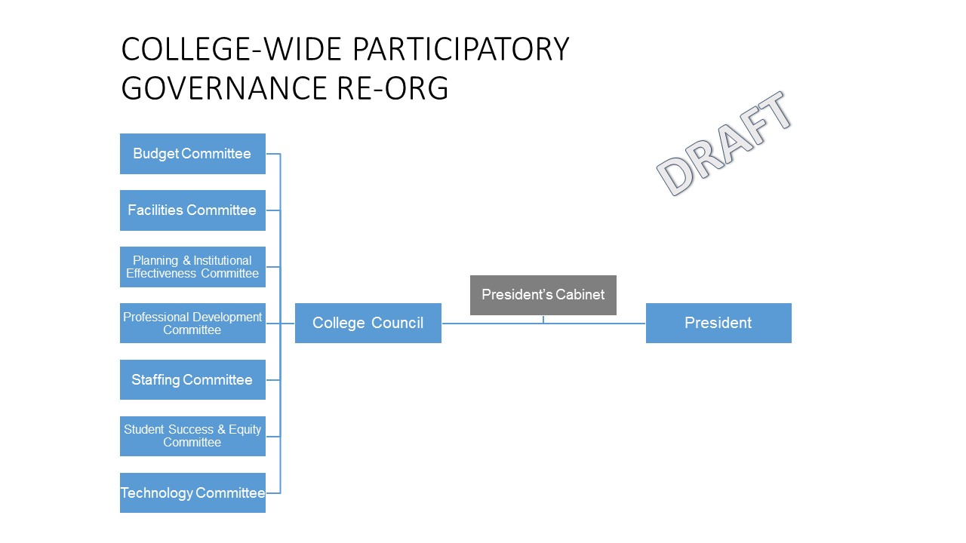

College Council

Purpose

The College Council is the apex governance body which provides guidance and recommendations to the College President regarding institutional policies, planning, and processes in support of the college mission. It engages all college constituency groups (students, faculty, classified professionals and supervisors/administrators) and the governance system as a whole through the maintenance of clear governance practices and policies, coordination of committee work across functions, and a commitment to continuous improvement and consensus building. The constituent-based representatives of this council serve the college by maintaining a broad, college-wide, and student-centered view of the needs of the institution - both in the weighing of the input from its committees and in bringing forward items for consideration and discussion. In all matters within its purview, it will maintain a focus on the goal of equitable outcomes for all students as a key value informing decision making.

Responsibilities

- Ensure transparent integration of annual unit planning processes and decision-making.
- Serve the needs of the governance committees by guiding, coordinating and supporting their ongoing efficacy and continuous improvement.
- Communicate ongoing conversations to the college constituencies and seek input and feedback on college-wide initiatives, plans, and procedures for effective decision-making.
- Review recommendations of the college governance committees (Budget, Facilities, Professional Development, Staffing, Student Success and Equity, and Technology) and make recommendations to the College President.
- Facilitate collaboration between governance committees when necessary to ensure effective progress in pursuit of the college’s mission and strategic goals.
- Convene the chairs of all governance committees once each term (for calendaring and planning in the fall and for continuous improvement feedback in the spring).
- Review and recommend institution-wide, categorical and other state-mandated plans for submission to the state.
- Ensure that college-wide plans, including the Educational Master Plan, Facilities Master Plan and Technology Master Plans, are evaluated and updated on a regular cycle to reflect current needs, goals and priorities.
- Regularly evaluate the effectiveness of the college’s overall planning processes, including the degree to which these processes promote inclusivity, equity and integrity, and institute improvements as necessary.
- Develop written responses to accreditation standards IV.A and IV.B and assist in the collection of evidence for other relevant standards.
- Regularly monitor student equity data to inform decision-making regarding policies, procedures and planning.
- Annually evaluate the participatory governance structure and process, including standing committees and the College Council

Member Responsibilities:
Standard committee member roles and responsibilities as outlined in the Grossmont College Governance Handbook (see page 9)

In addition, College Council members will:
- participate in college-wide planning events and training as necessary during the year;
- read all unit Program Review Summary Reports to maintain a broad and current understanding of programs’ practices and needs; and
- read materials from a variety of local, state and national entities (as forwarded by the Council Chairs) to stay current on emerging needs, priorities, policies and practices.

Membership
Convener (non-voting chair):
College Vice President (Rotates annually between VPAA, VPSS, VPAS)
Constituency Members:
ASGC President/designee + three representatives
Academic Senate President/designee + three representatives
Classified Senate President/designee + three representatives
Administrators' Association President/designee + three representatives
Ex-officio members:
None
Advisory Members
VPAA
VPSS
VPAS

Meeting Schedule
Fourth Thursday, 3:00-5:00

Quorum:
A quorum is achieved when 50 percent plus one of voting members are in attendance.

Consensus
If at least 75 percent of voting members reach agreement, and if there are no more than two (2) members from any one constituency who disagree, then consensus is reached.

Proxies
Each constituency may send up to two proxy attendees per meeting. Proxy attendees are given full discussion and decision-making rights.

Standing Committees

Standing committees are composed of constituency representatives and are permanent parts of the internal governance process of the college. Standing committees have an ongoing purpose and meet regularly to consider matters pertaining to their designated charge and report their recommendations to the College Council.

Quorum
The quorum is achieved when 50 percent plus one of voting members are in attendance.

Consensus
Consensus is reached when 75% of those present are in agreement.

Proxies
Each constituency may send up to two proxy attendees per meeting. Proxy attendees are given full discussion and decision-making rights.

Budget Committee

Purpose
The Budget Committee encourages transparency and constituency understanding of the budget, works to ensure that the budget allocation process is driven by college-wide planning and strategic priorities, and provides recommendations to the College Council on issues related to budget development and management.
In addition, the Budget Committee provides ongoing oversight in relation to budget changes and information at the State and District levels.
Responsibilities
- Receive information regarding ongoing state and District fiscal activities and review and discuss information on the state and District budgets as they apply to the College budget.
- Become educated about how the College’s revenue and expenditure budgets are developed to provide a context in which to effectively carry out the responsibilities of the committee.
- Develop, interpret, recommend and communicate assumptions, priorities, guidelines and procedures related to budget processes and resource allocation integrating recommendations from the educational, technology and facilities master plans.
- Provide ongoing education for the college community on budget development and implementation.
- Disseminate information to administrative, faculty, classified and student constituencies regarding the College’s financial resources and expenditures and bring feedback through Committee representatives.
- Review budget augmentation or reduction requests submitted through Annual Unit Plans ((Annual Unit Plans are influenced by Program Review, but the AUP contains annual operational needs as well as six-year strategic recommendations)) based on College priorities and submit recommendations to College Council.
- Continually compile evidence related to accreditation Standard III.D, as well as other relevant accreditation requirements, and monitor the college’s ongoing compliance with these requirements.
- Ensure ongoing attention to equitable educational outcomes and that needs of underrepresented populations and students with special needs are considered and addressed in the budget development process.

Membership
Co-chairs:
Vice President, Administrative Services
Classified or Faculty selected by constituency group from committee membership (Rotates annually)
Constituency Members:
3 members each from Classified Senate, Academic Senate, Students, Administrators’ Association.
Ex-officio members:
None
Advisory members:
Vice President of Academic Affairs
Vice President of Administrative Services
Vice President of Student Services

Meeting Dates
Second Thursday, 3 – 4:30 p.m.

Link to agendas and minutes:

Accreditation Standard
Standard III.D.

Technology Committee

Purpose
The Technology Committee identifies, prioritizes and advocates for the College’s technology needs and services. It makes recommendations to the College Council for the strategic direction and implementation of technology priorities. These recommendations address technology policies and procedures, prioritization of technology requests from annual unit plans, infrastructure requirements for existing programs, and projected needs of the college for the future. The committee will ensure that its recommendations are consistent with the objectives established in the Technology Plan, Strategic Plan, Educational Master Plan and other supporting plans (Human Resources, Facilities, etc.).
In addition, the Technology Committee maintains currency in relation to technology changes and information from industry, the District and the State Chancellor’s Office.

Responsibilities
- Make recommendations for the strategic direction and implementation of technology resources used throughout the college to support student learning programs and services, operations, and improve institutional effectiveness.
- Consider total cost of ownership, including renewal costs and maintenance, of college technology recommendations.
- Develop/update the College Technology Master Plan as needed with specific objectives for action and improvement, and recommend and communicate related policies, guidelines, and procedures.
- Prioritize technology requests from the annual unit plans (annual updates to the program review).
- Monitor the progress toward the implementation of the College’s Technology Master Plan.
- Ensure ongoing attention to equitable educational access and outcomes, and removal of barriers for historically underserved populations and students with disabilities in technology planning and the technology prioritization process.
- Ensure that the infrastructure and design of all College buildings support the future use of technology.
- Work with the Professional Development Committee to recommend relevant technology training for college employees.
- Assess and recommend technology training provided through professional development, computer support and self-guided training systems to ensure that the technology training meets the needs of faculty and staff.
- Continually compile evidence related to accreditation Standard III.C, as well as other relevant accreditation requirements, and monitor the college’s ongoing compliance with these requirements.

Membership
Co-chairs:
Dean, Learning & Technology Resources
Classified or Faculty selected by constituency group from committee membership (Rotates annually)
Constituency Members:
2 members each from Classified Senate, Academic Senate, Students, Administrators’ Association.
Ex-officio members:
Associate Dean of Student Services
Distance Education Coordinator
Dean of Admissions and Records and Financial Aid
Instructional Media Tech Support
A.R.C. designee
Advisory members:
Vice President of Academic Affairs
Vice President of Administrative Services
Vice President of Student Services
Others as appointed by Co-chairs

Meeting Dates
Fourth Monday, 11 a.m. - 12:30 p.m.

Link to agendas and minutes:

Accreditation Standard
Standard III.C.

Facilities Committee

Purpose
The Facilities Committee identifies, prioritizes and advocates for the facilities needs and services. It makes recommendations to the College Council for the strategic direction and implementation of facilities priorities. These recommendations address facilities policies and procedures, prioritization of facilities requests from annual unit plans, facility requirements for existing programs, and projected facility needs of the college for the future. The committee will ensure that its recommendations are consistent with the objectives and recommendations established in the Facilities Plan, Strategic Plan, Educational Master Plan, and other supporting plans and reports (five-year capital outlay plan, use of space, scheduled maintenance, state and federal reports, etc.).

Responsibilities

- Develop/update the College FMP in accordance with long-term educational master planning projections; monitor the progress toward the implementation of the plan.
- Build institutional annual and long-term goals to develop and implement initiatives in accordance with the recommendation of the FMP, the 5-year capital outlay plan, use of space, scheduled maintenance and other state and federal reports.
- Act as a recommending body to the College Council for the construction, remodeling, and/or reassignment of existing and new facilities, including bond-funded construction.
- Study existing facilities and recommend alterations and improvements in response to the annual unit plans and emergent needs.
- Promote energy efficiency and conservation, sustainable construction and grounds management, and best practices for physical plant management.
- Ensure that all college spaces, and the campus as a whole, are intentionally designed to welcome and engage our diverse student, employee, and broader community populations.
- Ensure that college facilities are physically and electronically accessible to all.
- Continually compile evidence related to accreditation Standard III.B, as well as other relevant accreditation requirements, and monitor college’s ongoing compliance with these requirements.

Membership
Co-chairs:
Vice President Administrative Services or Director of Facilities (as appointed by the College President)
Classified or Faculty selected by constituency group from committee membership (Rotates annually)
Constituency Members:
2 members each from Classified Senate, Academic Senate, Students, Administrators’ Association.
Ex-officio members:
Vice President Administrative Services or Director of Facilities (non-chairing)
Coordinator, Accessibility Resource Center
Advisory members:
Associate Dean of Athletics
District Sustainability Specialist
Vice President of Academic Affairs
Master Class Scheduler, Instructional Operations

Meeting Dates
First Wednesday, 9:30 – 11 a.m.

Link to agendas and minutes:

Accreditation Standard
Standard III.B

Student Success and Equity Committee

Purpose
The primary purpose of the Success and Equity Committee is to support and lead innovative campus initiatives that strengthen student access and success in an environment that fosters equity, diversity, and inclusion. The Committee makes recommendations to the College Council regarding student success and equity initiatives, programs and plans.
Through the integrated efforts of academic and student services, the Student Success and Equity Committee engages in data analysis and dialogue to provide a platform for collaboration and communication which focus on equity-minded student success, a culture of inclusivity, global consciousness, and a respect for diversity across all student success and equity efforts and throughout the College.
The Student Success and Equity Committee also serves in a coordinating and advisory role with administrators who implement the work of approved plans.

Responsibilities
- Develop a shared vision for the College’s student access, success and equity efforts.
- In conjunction with the Planning and Institutional Effectiveness Committee, use student access, success and equity data and research to assess effectiveness of various programs and the college as a whole.
- Advise in the development and collaboration of the various college plans, grants, and initiatives that address student access, success, and equity efforts.
- Increase collegewide awareness of student access, success and equity efforts.
- Provide a venue to dialogue and integrate student access success and equity efforts collegewide.
- To help enhance the College's ability to be student-ready, identify disproportionately impacted and vulnerable student populations, and inform and support professional development and cultural competency preparation.
- Consult and coordinate with the Academic Senate to ensure appropriate engagement when dealing with Academic and Professional matters (the 10+1).
- Continually compile evidence related to accreditation Standard III.B. and Standard III.C., as well as other relevant accreditation requirements, and monitor college’s ongoing compliance with these requirements.

Membership

Co-chairs:
Dean, Student Success & Equity
Classified or faculty selected by constituency group (Rotates annually)
Constituency Members:
President, Academic Senate or designee + 2
President, Classified Senate or designee + 2
President, Associated Students or designee + 2
President, Administrators' Association or designee + 2

Ex-officio Members:
Associate Dean, Student Services
Coordinator, Basic Skills Initiative
Chair, Counseling
Vice President of Academic Affairs
Vice President of Student Services

Advisory members:
Sr. Dean, College Planning & Institutional Effectiveness
Dean, Admissions & Records and Financial Aid
Director, Title V
Dean, CTE and Workforce Development
District Research and Planning Analyst (campus-based)

Meeting Dates
Second Tuesday, 3 – 5 p.m.

Link to agendas and minutes:

Accreditation Standard
Standards II.B. and II.C.

Planning and Institutional Effectiveness Committee

Purpose
The goal of the Planning and Institutional Effectiveness Committee is to help the college maximize the utilization of resources to improve student learning and achievement by analyzing data. It uses environmental scan data and institutional outcomes to drive institutional responses, and to ensure effective and continuous quality improvement. The committee reviews program assessment results against the college’s mission, values, and strategic goals. The committee is also responsible for assuring the continuous integration of planning across the campus, regularly evaluates the college's progress to ensure institutional effectiveness, and reviews the EMP every five years.

Responsibilities
- Reviews the 10-year educational master plan and six-year strategic plan to ensure alignment, and evaluate its progress.
- Initiate and review the process for the periodic review of the mission, vision, and values.
- In conjunction with the Student Success and Equity Committee, use student access, success, and equity data and research to assess effectiveness of various programs and the college as a whole.
- Lead program review processes and facilitate data-informed conversations about department and institutional performance to drive long-term college planning.
- Evaluate institution-set standards and student achievement goals, including Scorecard and IEPI accountability metrics, and other student success outcome measures.
- Analyze data for and support the development of college plans and planning activities.
- Assist the College Council in development of evaluation plans for major initiatives/projects.
- Champion data-based decision making.
- Continually compile evidence related to accreditation Standard I.A., I.B, and I.C. as well as other relevant accreditation requirements, and monitor the college’s ongoing compliance with these requirements.

Membership
Co-chairs:
Senior Dean, College Planning and Institutional Effectiveness
Classified, Faculty or Student selected by constituency group (Rotates annually)
Constituency Members:
3 members each from Classified Senate, Academic Senate, Associated Students of Grossmont College, Administrators’ Association.
Ex-officio members:
Dean, Student Success and Equity
SLO coordinator
Data liaison(s)
Advisory members:
Vice President of Academic Affairs
Vice President of Student Services
Vice President of Administrative Services
District Planning and Research Analyst (campus-based)
Academic Program Review, co-chair
Student Services Program Review, chair

Meeting Dates
Third Friday, 11 a.m. – 12:30 p.m.

Link to agendas and minutes:

Accreditation Standard
Standards I.A., I.B., I.C.

Professional Development Committee

Purpose
The Professional Development Committee carries out planning and evaluation of professional development programming which support the institution’s continuous improvement and goals, and support its diverse personnel. The committee identifies emerging trends from annual unit plans and program review to inform professional development.

Responsibilities
- Establish professional development goals and activities to ensure employees are prepared to meet the needs of the diverse student and employee population.
- Cultivates an environment that values innovation and promotes collaboration in the service of student success.
- Foster a campus climate that improves employee satisfaction, retention, and success.
- Develops a comprehensive annual plan of activities based on college strategic goals, accreditation recommendations, evaluations, feedback, and surveys.
- Coordinate multiple professional development strands (classified, faculty, administrative) to ensure efficiency and effectiveness in the pursuit of college strategic goals.
- Plan FLEX activities.
- Review professional development requests.
- Work closely with the other college committees, district professional development, and the Human Resources Advisory Council (HRAC).
- Coordinate/communicate with the faculty professional development committee regarding faculty professional development.
- Continually compile evidence related to accreditation Standard III.A., as well as other relevant accreditation requirements, and monitor the college’s ongoing compliance with these requirements.

Membership
Co-chairs:
Dean, Student Success and Equity
Classified or Faculty selected by constituency group (Rotates annually)
Constituency Members:
2 members each from Classified Senate, Academic Senate, Associated Students of Grossmont College, Administrators’ Association
Ex-officio members
Professional Development Faculty Coordinator
Director, College and Community Relations
Professional Development Program Specialist
Advisory members:
Vice President, Academic Affairs
Vice President, Student Services
Vice President, Administrative Services

Meeting Dates
Third Wednesdays, 2 – 3:30 p.m.

Link to agendas and minutes:

Accreditation Standard
Standard III.A.

Staffing Committee

Purpose
The Staffing Committee is responsible for drafting Grossmont College’s multi-year Staffing Plan based on Educational Master Plan and Strategic Plan goals, and for monitoring the implementation of Staffing Plan to promote employment equity and diversity consistent with the college’s mission, vision and values. The Grossmont College Staffing Committee is responsible for prioritization of faculty and classified staffing requests from annual unit plans.

Responsibilities
- Establish Grossmont College Staffing goals based on strategic goals, accreditation recommendations, Faculty Obligation Number (FON), Educational Master Plan, staff equity and diversity goals, retirements, resignations, and enrollment projections.
- Create a long-term staffing plan.
- Coordinate with faculty and classified staffing ad hoc committees to create rubrics for use in prioritization of staffing requests from annual unit plans.
- Coordinate with faculty and classified staffing ad hoc committees regarding staffing prioritization recommendations to the College Council.
- Annually evaluate the staffing prioritization rubrics and their application period.
- Request and evaluate EEO data from the District to better inform the staffing plan.
- Continually compile evidence related to accreditation Standard III.A., as well as other relevant accreditation requirements, and monitor the college’s ongoing compliance with these requirements.

Membership
Co-chairs:
Vice President (Rotates annually to a VP who is not serving as the Chair of the College Council)
Classified, Faculty or Student selected by constituency group (Rotates annually)
Constituency Members:
3 members each from Classified Senate, Academic Senate, Students, Administrators’ Association.
Ex-officio members:
Senior Dean of College Planning
Dean of Student Success and Equity
Vice President of Academic Affairs
Vice President of Administrative Services
Vice President of Student Services

Meeting Dates
TBD

Link to agendas and minutes:

Accreditation Standard
III.A.

OPERATIONAL COMMITTEES

Operational entities are not constituency based; rather, they include the personnel to accomplish their operational tasks and conduct regular business. They make decisions on specific, functional issues, based on established local, state, and federal regulations, protocols, or procedures, or they may be established for other standing or temporary purposes. Operational committees also implement the decisions made as part of the participatory governance process.

Operational committee membership is based on appointment related to expertise and position, and do not represent constituency groups though their membership may reflect a wide variety of constituencies. Operational bodies are led by a chair, co-chairs or tri-chairs, depending on preference, interest in the issue, or subject matter expertise.
Operational committees can also be heavy in consultation with various campus departments or types of personnel, such as department chairs, to better complete the work of the committee.

Student Representation
Membership on operational bodies is largely assigned by position, department or division, except when it comes to student representation as outlined by California Code of Regulations, Title, Section 51023.7, more commonly known as "9+1," or by GCCCD board policy. The 9+1 policies include:
- Grading policies
- Codes of student conduct
- Academic disciplinary policies
- Curriculum development
- Courses or programs that should be initiated or discontinued
- Processes for institutional planning and budget development
- Standards and policies regarding student preparation and success
- Student services planning and development
- Student fees within the authority of the District to adopt
- Any other District and college policy, procedure, or related matter that the District governing board determines will have significant effect on students
While student participation is regulated, it's also important to include students in decisions that will directly affect them. Program and policy decisions are enhanced when considering student development.

Types of operational bodies
There are several different types of operational committees or bodies; they are called together based on the needs of the college.

Council
Councils are primarily bodies that represent functional areas and provide counsel to their respective vice president or dean.

Committee
Committees have a specific purpose within a defined scope of responsibility.

Steering Committee
Steering committees are charged with overseeing and directing large-scale initiatives and may oversee other committees.
Advisory Committee
Advisory committees serve to provide consultative and technical assistance to program/department staff.
Ad Hoc/Task Force
Ad hoc and task forces are generally groups with very task-oriented goals and are considered a working group that includes membership from across the college. They typically exist for a limited amount of time.

Work Group
Work groups are more constrained in assignment scope and in membership, often times with membership confined to one department, initiative or program. They typically exist for a limited amount of time.

Operational Committees
Below are current operational bodies by division:

Academic Affairs
Academic Affairs Council
Academic Division Councils (Allied Health and Nursing; Arts, Language and Communications; Career Technical Education and Workforce Development; English and Social/Behavioral Sciences; Learning and Technology Resources; Math, National Sciences, Exercise Science and Wellness)
CTE Advisory Committees
Enrollment Strategies Committee

Administrative Services
Administrative Services Council
Administrative Services Program Review
Bookstore Committee
Emergency Preparedness Committee
Food Services Advisory Committee

Student Services
Student Services Council
Admissions and Records Appeal Committee
International Programs Committee
Financial Aid Appeals Committee
Scholarships Committee
Basic Needs Task Force
Disciplinary Hearing Committee
Formal Student Grievance Hearing Council
Student Services Program Review
Veterans Services Task Force
World Arts & Culture Committee
SSSP Committee
Title V Steering Committee
CARE Advisory Committee
CalWORKs Advisory Committee
EOPS Advisory Committee

Collegewide/President's Office
Accreditation Steering Committee
Annual Unit Plan Task Force
College Recognition Committee
Leadership Council
Marketing Committee
Guided Pathways Convening Task Force

APPENDICES
AP/BP
10+1
9+1
ACCJC standards

