Exam 1

Part 1: Multiple Choice (2 points each)

Directions: Please circle the best answer for each of the following questions.
- John Dalton postulated that all matter is composed of small particles called atoms. For this proposition to be considered a valid scientific theory,
  - it must be supported by experimental evidence and testing.
  - it must be impossible to prove wrong by experiment.
  - all possible experiments must never find an exception to it.
  - some, but only a few, experiments may find exceptions to it.
  - it must be voted on by the scientific community and accepted by all.

- Which particle-level diagram is the best representation for a 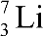 atom?
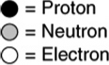
a. 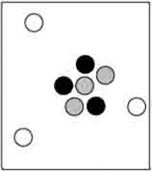 c. 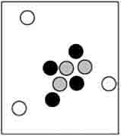
b. 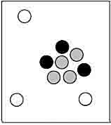 d. 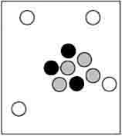
e. none of the above

- Elements in group 18 (VIIIA) are called
  - alkali metals
  - alkaline earth metals
  - halogens
  - chalcogens
  - noble gases

- Name the term for the energy associated with the heat.
  - Kinetic energy
  - Potential energy
  - Mechanical energy
  - Electrical energy
  - Thermal energy

- Extraction is
  - a process in which the more volatile liquid is boiled off.
  - dissolving a liquid or solid with a liquid to remove another solid/liquid that dissolves in that liquid.
  - separating a solid from a liquid by pouring off the liquid.
  - pouring a mixture through a filter paper to separate the solid from the liquid.
  - heating a mixture of two solids to fuse them together.

- How many electrons can be contained in the following figure:
  - s orbital
  - p orbital
  - 2 electrons
  - 6 electrons
  - b and d

- What is the chemical symbol for the iron(III) ion?
  - Fe²⁺
  - Fe³⁺
  - ferric ion
  - ferrous ion
  - F³⁺

- On the electromagnetic spectrum, visible light is immediately between two other wavelengths. Name them.
  - infrared and x-ray
  - radio and microwave
  - gamma ray and ultraviolet
  - microwave and x-ray
  - infrared and ultraviolet

- Manganese, gold, tungsten, and yttrium are all classified as
  - alkali metals
  - alkaline earth metals
  - transition metals
  - inner transition metals
  - transuranium elements

- 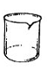Name the piece of equipment:
  - Graduated cylinder
  - Erlenmeyer flask
  - Scoopula
  - Beaker
  - Watch glass

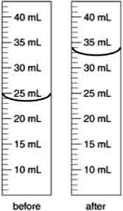
Part 2: Short Answer

Directions: Answer each of the following questions. Be sure to use complete sentences where appropriate. For full credit be sure to show all of your work.
- An irregularly shaped metal object with a mass of 25.43 g was placed in a graduated cylinder with water. The before and after volumes are shown below (8 points).
  - What is the volume of the metal object?

  - What is the density of the metal?

  - If the actual density of the metal is 2.82 g/mL, what is the percent error?

- What is the difference between weight and mass (3 points)?

- How might you use filtration to separate a mixture of salt and sand (3 points)?

- List all of the physical properties and changes in the following statement: “The temperature of the land is an important factor for the ripening of oranges, because it affects the evaporation of water and the humidity of the surrounding air.” (3 points)

- Write the nuclear symbol, ${}_{Z}^{A}{Sy}$, for each of the following isotopes (8 points):
  - a nitrogen atom with 8 neutrons. ________________________
  - an atom with 20 protons, 22 neutrons, and 18 electrons ________________________
  - an atom with mass number 27 and 14 neutrons ________________________
  - an oxide ion with 9 neutrons ________________________

- Consider three elements with the following noble gas notations (8 points):
X = [Ar] 4s²; Y = [Ne] 3s²3p⁴; Z = [Ar] 4s²3d¹⁰4p⁴
  - Identify each element: X = _______, Y = _______, Z = _________
  - Which element has the largest atomic radius? __________________
  - Which elements have similar properties? __________________
  - Which element has the highest ionization energy? __________________
  - Which element has the most metallic character? __________________

- A bullet is traveling 922 miles/hour. How fast is it going in m/s (8 points)?

- The density of air at ordinary atmospheric pressure and 25 °C is 1.19 g/L. What is the mass, in kilograms, of the air in a room that measures 12.5 ft x 15.5 ft x 8.0 ft (8 points)?

- The results from Thomson’s cathode-ray tube experiment led to the discovery of which subatomic particle (2 points)?

- Complete the following table (24 points):
 | Name | Cation | Anion | Formula
 | Xenon trioxide | -------------------- | --------------------
 | Zinc nitride
 |  |  |  | KBr
 | Hydrogen fluoride
 |  | Na⁺ | H⁻
 |  |  |  | BaI₂
 | Lithium sulfide
 | Ammonia | ------------------- | --------------------
 | Diphosphorus tetrachloride | ------------------- | -------------------
 |  | -------------------- | --------------------- | CO
 |  | -------------------- | --------------------- | N₄Se₄

- Arrange the following steps in the scientific method in the sequence in which they normally occur (5 points).
  - Suggest probable explanations for generalizations obtained from data.
  - Collect data concerning a problem through observation and experimentation.
  - Identify a problem, and carefully plan procedures to obtain information about all aspects of this problem.
  - Experiment further to prove or disprove explanations.
  - Analyze and organize data in terms of general statements that summarize experimental observations.

