Exam 1

Part 1: Multiple Choice (2 points each)

Directions: Please circle the best answer for each of the following questions.
- Which element is not a representative element?
  - Aluminum
  - Sulfur
  - Potassium
  - Boron
  - Iron

- Which of the following numbers are correctly expressed in scientific notation?

i. 43,200,000 = 4.32×10⁷ ii. 0.000977 = 9.77×10⁴ iii. 606,000 = 6.06×10^{–5} iv. 0.00000175 = 1.75 × 10^{–6}

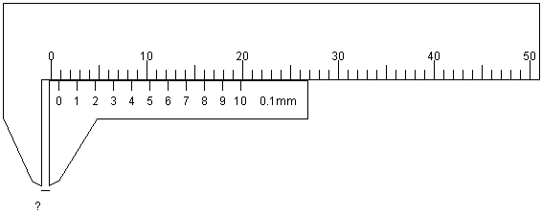
- i and iv
- ii and iii
- i and iii
- ii and iv
- All of the above

- What is the measurement shown by the calipers?
  - 0 mm
  - 0.8 cm
  - 10.5 cm
  - 19.8 cm
  - 26.8 cm

- Convert 32.7 m to mm.
  - 32,700 mm
  - 0.0327 mm
  - 327 mm
  - 0.0327 mm
  - 0.327 mm

- Consider a situation in which you are walking at 3.7 miles per hour. Which of the following per expression is true?
  - 3.7 mi = 1 hr
  - $\frac{3.7 mi}{1 hr}$
  - $\frac{1 hr}{3.7 mi}$
  - Distance in miles is directly proportional to time in hours.
  - all of the above

- Which of the following most accurately describes the change represented:
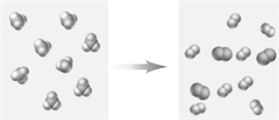
  - A physical change which follows the law of conservation of mass.
  - A physical change which does not follow the law of conservation of mass.
  - A chemical change which follows the law of conservation of mass.
  - A chemical change which does not follow the law of conservation of mass.
  - none of the above

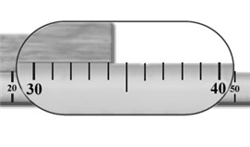
- The meter stick in the image is being used to measure the length of a piece of wood. How many significant figures should be used to express this measured length?

  - 1
  - 2
  - 3
  - 4
  - 5

- Isotopes of an element vary in mass because of differing numbers of
  - protons
  - neutrons
  - electrons
  - protons and neutrons
  - protons and electrons

- Which statement is consistent with Rutherford’s nuclear model of the atom as it was originally stated?
  - Helium atoms have two protons in the nucleus and two electrons outside the nucleus.
  - Most of the volume of hydrogen atoms is due to the nucleus.
  - Aluminum atoms have 13 protons in the nucleus and 22 electrons outside the nucleus.
  - The majority of the mass of nitrogen atoms is due to their 7 electrons.
  - all of the above

- Tasting chemicals
  - is allowed for solutions that are very dilute.
  - is allowed for lab chemicals that we also know are “common chemicals”.
  - is allowed for chemicals that are known to be nontoxic.
  - is never allowed in chemistry labs.
  - all of the above

Part 2: Short Answer

Directions: Answer each of the following questions. Be sure to use complete sentences where appropriate. For full credit be sure to show all of your work.
- A chemist in an imaginary universe does an experiment that attempts to correlate the size of an atom with its chemical reactivity. The results are tabulated as follows (6 points).
Size of Atom | Chemical Reactivity
small | low
medium | intermediate
large | high
  - Formulate a law from this data.

  - Formulate a theory to explain this law.

- Write the chemical formulas for compounds containing (6 points):
  - Three iron atoms for every four sulfur atoms. ____________
  - Two hydrogen atoms for every one oxygen atom. ____________
  - One phosphorus atoms for every three chlorine atoms. ____________
- Answer the following questions about the reaction of potassium metal, K, and hydrogen gas, H₂, to produce potassium hydride, KH (8 points).
2 K _{(s)} + H_{2 (g)} → 2 KH _{(s)}
  - Identify KH _{(s)} as a reactant or product. __________________
  - Identify K _{(s)} as a reactant or product. __________________
  - What is the name of the group K _{(s)} falls into? __________________
  - What is the state of H_{2 (g)}? __________________
  - What is the state of KH _{(s)}? __________________
  - Calculate the mass of potassium needed to react with 4.50 g of hydrogen gas to produce 179.05 g of potassium hydride.

- If 1.4% of the mass of a human body is calcium, how many kilograms of calcium are there in a 173 pound man (8 points)?

- The density of balsa wood is 0.16 g/cm³. What is mass, in grams, of 6.78 ft³ of balsa wood (8 points)?

- Identify each of the following as a solid, liquid, or gas (5 points).
  - Vitamin tablets in a bottle __________________
  - Helium in a balloon __________________
  - Milk in a bottle __________________
  - The air you breathe __________________
  - Charcoal briquettes on a barbecue __________________
- What are the forms of energy involved in the following examples (6 points):
  - light bulb ______________________________________________________
  - heater ______________________________________________________
- Nail polish remover, acetone, boils at 56.05 °C (8 points).
  - What is the boiling point in degrees Fahrenheit?

  - What is the temperature in Kelvin?

- Determine whether each statement is true or false. If false, correct it (5 points).
  - The Ti²⁺ ion contains 22 protons and 24 electrons.
  - The I⁻ ion contains 53 protons and 54 electrons.
  - The Mg²⁺ ion contains 14 protons and 10 electrons.
- An element has two naturally occurring isotopes. Isotope 1 has a mass of 120.9038 u and a relative abundance of 57.4%, and isotope 2 has a mass of 122.9042 u (10 points).
  - What is the percent abundance of the second isotope?

  - What is the atomic mass of the element?

  - What is the name and symbol of the element? ______________________________

- Label each of the following pieces of laboratory glassware with their correct names: crucible tongs; evaporating dish; scoopula; Erlenmeyer flask; beaker (5 points).
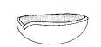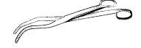

- In an experiment similar to part 1 of the Mass, Volume, Density experiment the following data was collected (10 points).
  - Complete the table below:
Mass of beaker and solution | 125.447 g
Mass of beaker | 99.887 g
Mass of solution
Volume of solution | 24.3 mL
Density of solution
Actual Value | 1.034 g/mL
Percent error
  - If some of the solution spilled after the volume was measured, how would that change the density (too high, too low, unchanged)? Explain your answer.

