Exam 4

Part 1: Multiple Choice (2 points each)

Directions: Please circle the best answer for each of the following questions.

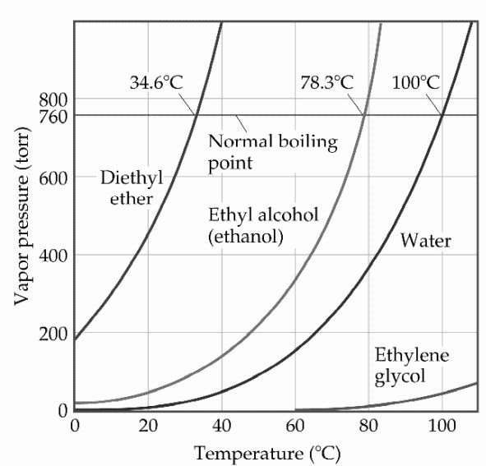
- Based on the figure above, the boiling point of diethyl ether under an external pressure of
0.855 atm is ________°C.
  - 0
  - 10
  - 20
  - 30
  - 40

- ______________ has the strongest intermolecular forces.
  - A2X, ΔHvap= 39.6 kJ/mol
  - BY2, ΔHvap= 26.7 kJ/mol
  - C3X2, ΔHvap= 32.5 kJ/mol
  - DX2, ΔHvap= 23.3 kJ/mol
  - EY3, ΔHvap= 21.6 kJ/mol

- Identify the technique that determines the arrangement of atoms and measures the distance between them.
  - x-ray diffraction
  - ultraviolet
  - nuclear magnetic resonance
  - infrared
  - atomic absorption

- Which of the following represent the addition polymer formed from: CH2=CH-CH3
  - 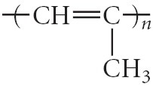
  - 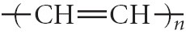
  - 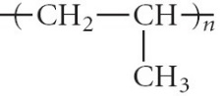
  - 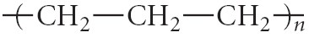

- Describe what happens when seawater is consumed to quench thirst.
  - Seawater can quench thirst once it is boiled.
  - Seawater quenches thirst when directly ingested.
  - Seawater draws water out of the body resulting in further dehydration and diarrhea.
  - Seawater helps diarrhea.
  - Seawater must be ingested at twice the volume to quench thirst.

- Which of the following compounds will be most soluble in ethanol (CH3CH2OH)?
  - trimethylamine (N(CH3)3)
  - acetone (CH3COCH3)
  - ethylene glycol (HOCH2CH2OH)
  - hexane (CH3CH2CH2CH2CH2CH3)
  - none of these compounds should be soluble in ethanol.

- In a reaction mixture containing only reactants, what is the value of Q?
  - -1
  - 1
  - ∞
  - 0
  - It cannot be determined without concentrations.

- Express the equilibrium constant for the following reaction: 10 N2(g) + 30 H2(g) ⇔ 20 NH3(g)
  - K = 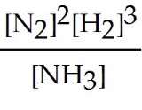
  - K = 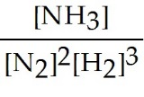
  - K = 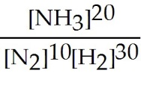
  - K = 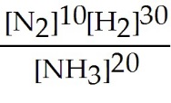
  - K = 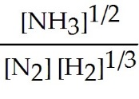

- What is Δn for the following equation in relating Kc to Kp?
C3H8(g) + 5 O2(g) ⇌ 3 CO2(g) + 4 H2O(l)
  - 3
  - 1
  - -3
  - 2
  - 6

- When using a pipet it is an acceptable technique
- to pipet by mouth because it provides the best suction and control.
- use a pipet without first conditioning it.
- suction the liquid below the calibration line and then add that to your reaction flask.
- suction the liquid above the calibration line and then add that to your reaction flask.
- none of the above

Part 2: Short Answer

Directions: Answer each of the following questions. Be sure to use complete sentences where appropriate. For full credit be sure to show all of your work.
- The vapor pressure of ethanol is 115 torr at 34.9 °C. If ∆H_{vap} of ethanol is 38.6 kJ/mol, calculate the temperature (in °C) when the vapor pressure is 101.325 kPa (8 points).

- A solution contains 3.5 moles of water and 1.5 moles of nonvolatile glucose (C₆H₁₂O₆) (8 points).
  - What is the mole fraction of water in this solution?

  - What is the vapor pressure of the solution at 25 °C, given that the vapor pressure of pure water at 25 °C is 23.8 torr?

- How does the sea of electrons model explain the high electrical conductivity of gold? How does band theory explain this (3 points)?

- Define triple point (3 points).

- Describe the difference between the conduction band and the valence band (3 points).

- An XRD analysis (λ = 154 pm) of a sample of copper has peaks at 2θ = 24.64° (n = 1), 50.54° (n = 2), and 79.62° (n =3). What is the distance (d) between layers of Cu atoms that could produce this diffraction pattern (8 points)?

- Why is the ΔHvap higher than ΔHfus for a given compound (3 points)?

- Determine the Henry's law constant for ammonia in water at 25°C if an ammonia pressure of 0.022 atm produces a solution with a concentration of 1.3 M (4 points).

- What happens to a supersaturated solution of potassium acetate once it is cooled and a small crystal of solid potassium acetate is added (3 points)?

- Is the following statement true or false? For solutions of the same reverse osmotic pressure at the same temperature, the molarity of a solution of NaCl will always be less than the molarity of a solution of CaCl₂. Explain your answer (3 points).

- Explain why a needle floats on the surface of water but sinks in a container of methanol, CH₃OH (3 points).

- Explain why pipes filled with water are in danger of bursting when the temperature drops below 0 °C (3 points).

- Explain what happens to a substance when it is heated in a closed container to its critical temperature (3 points).

- Consider the following reaction at equilibrium (5 points).
4 FeS2 (s) + 11 O2 (g) ⇌ 2 Fe2O3 (s) + 8 SO2 (g)
  - What will happen if FeS2 is added to the reaction? ________________________
  - What will happen if O2 is added to the reaction? ________________________
  - What will happen if Fe2O3 is added to the reaction? ________________________
  - What will happen if the pressure increased? ________________________
  - What will happen if the volume increased? ________________________

- A 50.0 L reaction vessel contains 1.00 mol of nitrogen gas, 3.00 mol of hydrogen gas, and 0.500 mol of ammonia. Will more ammonia be formed or will it dissociate when the mixture goes to equilibrium at 400 °C (8 points)?
N_{2 (g)} + 3 H_{2 (g)} $⇌$ 2 NH_{3 (g)} K_{c} = 0.500

- At high temperatures, a dynamic equilibrium exists between carbon monoxide, carbon dioxide, and solid carbon. At 850 °C, K_{c} is 0.153 (12 points).
C _{(s)} + CO_{2 (g)} $⇌$ 2 CO _{(g)} ∆H° = 172.5 kJ
  - What is the value of K_{p}?

  - If the original reaction system consisted of 1.00 g of carbon and 1.50 atm of carbon dioxide, what are the pressure of carbon dioxide and carbon monoxide when equilibrium is established?

  - How will the equilibrium pressure of carbon monoxide change if the temperature is decreased?

