Exam 1

# Part 1: Multiple Choice (2 points each)

## Directions: Please circle the *best* answer for each of the following questions.

1. What is the most effective method for avoiding exposure by ingestion?
   1. Taste only chemicals that your instructor gives you permission to taste.
   2. Taste only chemicals that you know are nontoxic.
   3. Never eat or drink anything while in a chemistry lab.
   4. Only eat food in the lab when you know that it cannot be contaminated with toxic chemicals.
   5. all of the above
2. If Kc is the equilibrium constant for a forward reaction, 2 A $⇌$ B, what is K’c for the reaction 4 A $⇌$ 2 B?
   1. ½ Kc
   2. Kc
   3. 2 Kc
   4. (Kc)2
   5. none of the above
3. What is true about the relationship of Kp and Kc for the reaction: 2 CH­4 (g) + 3 O2 (g) 2 CO (g) + 4 H2O (g)
   1. Kp < Kc
   2. Kp = Kc
   3. Kp > Kc
   4. Kp and Kc are not related
   5. none of the above
4. 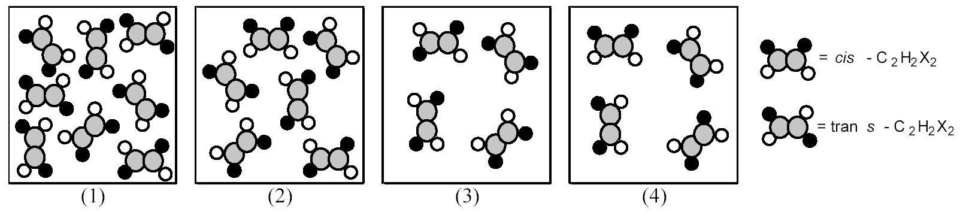The following pictures represent the mixtures of cis-C2H2X2 molecules and trans-C2H2X2 molecules, which interconvert according to the equation: cis-C2H2X2  trans-C2H2X2. If mixture (1) is at equilibrium, which of the other mixtures is also at equilibrium?
   1. Mixture (2)
   2. Mixture (3)
   3. Mixture (4)
   4. Mixture (2) and (4)
   5. none of the above
5. Which of the following species cannot act as a Lewis base?
   1. CH4
   2. O2-
   3. H2O
   4. NH3
   5. none of the above
6. Which one of the following salts, when dissolved in water, produces the solution with a pH closest to 7.00?
   1. NH4Cl
   2. BaO
   3. NaHSO4
   4. RbI
   5. HCl
7. What is the approximate pH of a solution X that gives the following responses with the indicators shown?

|  |  |  |  |
| --- | --- | --- | --- |
| Indicator | HIn – In- | pH range | Solution X |
| Methyl orange | Red-yellow | 3.2 – 4.4 | Yellow |
| Methyl red | Red-yellow | 4.8 – 6.0 | Yellow |
| Bromothymol blue | Yellow-blue | 6.0 – 7.6 | Green |
| Phenolphthalein | Colorless-pink | 8.2 – 10.0 | Colorless |

* 1. 3.2 – 4.4
  2. 4.8 – 6.0
  3. 6.0 – 7.6
  4. 8.2 – 10.0
  5. not enough information

1. Which statement is true about buffers?
   1. Buffers have pH = 7
   2. Buffers consist of a strong acid and its conjugate base.
   3. A buffer does not change pH on addition of a strong acid or strong base.
   4. Buffers consist of a strong base and its conjugate acid.
   5. Buffers resist change in pH upon addition of small amounts of strong acid or strong base.



The following plot shows two titration curves, each representing the titration of 50.00 mL of 0.100 M acid with 0.100 M NaOH.

1. Which point a-d represents the equivalence point for the titration of a strong acid?
   1. a
   2. b
   3. c
   4. d
   5. none of the above
2. At which point a-d is the pKa of the acid equal to the pH?
   1. a
   2. b
   3. c
   4. d
   5. none of the above

# Part 2: Short Answer

## Directions: Answer each of the following questions. Be sure to use complete sentences where appropriate. For full credit be sure to show all of your work.

1. Calculate K for the reaction (6 points):

SnO2 (s) + 2 CO (g) Sn (s) + 2 CO2 (g) K = ?

given the following information:

SnO2 (s) + 2 H2 (g) Sn (s) + 2 H2O (g) K1 = 8.12

H2 (g) + CO2 (g) H2O (g) + CO (g) K2 = 0.771

1. Consider the following equilibrium system in a closed container (8 points):

FeS (s) + 2 H+ (aq) ⮀ Fe2+ (aq) + H2S (g) ∆H < 0

|  |  |  |  |
| --- | --- | --- | --- |
| Change | Direction of shift | Effect on quantity | Effect (i, d, nc) |
| Add Fe2+ (aq) |  | Kc |  |
| Lower temperature |  | Kc |  |
| Add FeS (s) |  | H+ (aq) |  |
| Remove H2S ­(g) |  | Amount of FeS (s) |  |

1. The values of Ka for phenol and 2,4,6-trichlorophenol are 1.3 x 10-10 and 1.0 x 10-6, respectively. Which is the stronger acid? Account for the differences in acid strength using the structures below (5 points):

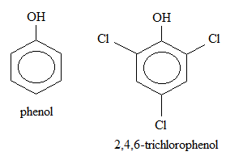

1. If a 0.500 L flask containing 1.25 × 10-4 mol hydrogen sulfide gas is heated to 800 °C,

2 H2S (g) 2 H2 (g) + S2 (g) Kc = 1.67 × 10-7 M (15 points)

* 1. find the equilibrium concentrations.
  2. determine Kp .

1. Bromocresol green, Ka = 2.0 x 10-5, is yellow in its protonated form (HX) and blue in its ionized form (X-) (6 points).
   1. At what pH will bromocresol green be a perfect green color?

* 1. What is the effective range of the buffer? __________________
  2. What color would bromocresol green solution be at pH = 7? ____________

1. Does the pH of the solution increase, decrease, or stay the same when you (3 points)
   1. add solid ammonium chloride to a dilute aqueous solution of ammonia? ____________
   2. add solid sodium acetate to a dilute aqueous solution of acetic acid? ____________
   3. add solid sodium chloride to a dilute aqueous solution of sodium hydroxide?__________
2. Do both protons ionize instantaneously from a diprotic acid such as H2CO3? Explain your answer (4 points).
3. The experimental pH of a 0.25 M NaC2H3O2 solution is 9.020. The theoretical pKa is 4.756 (18 points).
   1. Calculate the [H+].
   2. Calculate the pOH.
   3. Calculate the [OH-].
   4. Write the balanced net ionic equilibrium reaction. Identify the acid, base, conjugate acid, and conjugate base. Then calculate the equilibrium concentration of all species using an ICE table.
   5. Calculate the experimental Kb value.
   6. What is the percent error?
   7. Calculate the experimental pKb value.
   8. Calculate the percent protonation.
   9. Without preforming a calculation, explain how would the percent protonation change in the presence of 0.10 M NaOH?
4. Consider the titration of 25.00 mL of 0.100 M formic acid, HCOOH, Ka = 1.8 x 10-4, with 0.150 M sodium hydroxide (15 points).
   1. What is the balanced net ionic equation for the reaction?
   2. What volume of base is required to reach the equivalence points?
   3. What is the pH at the equivalence point in the titration? Hint use an ICE table.