Quiz 4

Directions: Answer each of the following questions. Be sure to use complete sentences where appropriate. For full credit be sure to show all of your work. Where appropriate answers should be boxed for clarity, written to the correct number of significant figures, and, include the proper units.
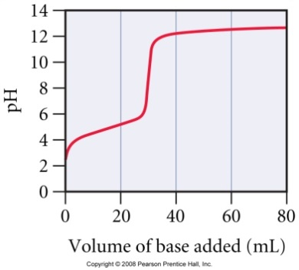
- Consider the curve for the titration of a weak monoprotic acids with a strong base and answer each question (12 points).
  - What is the pH and what is the volume of added base at the equivalence point?
The equivalence point of a titration is where the pH rises sharply as base is added. The volume at the equivalence point is ~30 mL, which is ~pH 9
  - At what volume of added base is the pH calculated by working an equilibrium problem based on the initial concentration of K_{a} of the weak acid?
At 0 mL the pH is calculated by doing an equilibrium calculation of a weak acid in water.
  - At what volume of added base does pH = pK_{a}?
The pH one-half way to the equivalence point is equal to the pK_{a} of the acid or ~15 mL.
  - At what volume of added base is the pH calculated by working an equilibrium problem based on the concentration and K_{b} of the conjugate base?
The pH at the equivalence point, or ~30 mL, is calculated by doing an equilibrium problem with the K_{b} of the acid. At the equivalence point all of the acid has been converted to its conjugate base.
  - Beyond what volume of added base is the pH calculated by focusing on the amount of excess strong base added?

Beyond the equivalence point, or ~30 mL, there is excess base. All of the acid has been converted to its conjugate base and so the pH is calculated by focusing on this excess base concentration.
- What is the pH at 25 °C of a saturated solution of silver hydroxide, given K_{sp} = 1.52 x 10⁻⁸ (8 points)?
There are two ways you can solve this problem:
AgOH _{(s)} $⇌$ Ag⁺ _{(aq)} + OH⁻ _{(aq)} K_{sp} = 1.52 x 10⁻⁸ = [Ag⁺][OH⁻]
I n/a 0 M 0 M 1.52 × 10⁻⁸ = s²
C n/a +s +s s = 1.23 × 10⁻⁴ M
E n/a s s
1.23 × 10⁻⁴ 1.23 × 10⁻⁴ M
pOH = -log[OH⁻] = -log(1.23 × 10⁻⁴) = 3.909
pH = 14 – 3.909 = 10.091
or
You can also calculate S using the equation:
$$S=\sqrt{\frac{K_{sp}}{a^{a}b^{b}}}=\sqrt{\frac{1.52×{10}^{-8}}{(1^{1})(1^{1})}}=1.23×{10}^{-4} M$$
pOH = -log[OH⁻] = -log(1.23 × 10⁻⁴) = 3.909
pH = 14 – 3.909 = 10.091

