Math 176: Graphing Piecewise Defined Functions
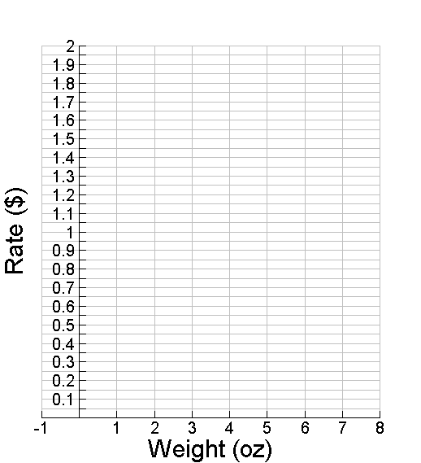
Example #1: Step Function

First-Class Mail Rates
First ounce | $0.45
Each additional ounce  (up to 13 oz) | $0.20

Weight not over (ounces) | Rate ($)
1
2
3
4
5
6
7
8

Example #2: Piecewise Defined Function

Let $f(x)$ be a piecewise defined function defined by

1. SEE BOTTOM OF PAGE: Start by graphing each of the functions on 3 separate graphs.

2. Cut along the dotted lines.

3. Determine what piece/part (domain) of each graph you need to use to construct the piecewise defined function: How many pieces is the x-axis cut into?

4. By cutting or folding along vertical lines, construct the correct graph of g(x). Use it to accurately graph g(x) on the grid below. Make sure to indicate any closed or open circles/holes in the graph. (These may occur where one piece ends and another begins)
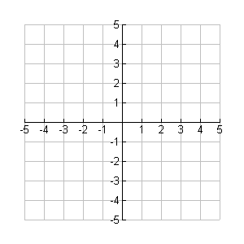

State the Domain of g(x).

State the Range of g(x).

cut here cut here cut here cut here cut here

Practice Graphing Piecewise Defined Functions:

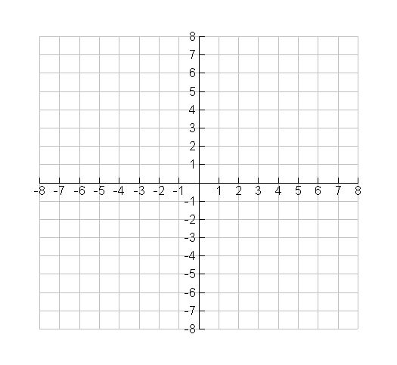
- Graph:

Domain of f(x):

Range of f(x):

- Graph:

Domain of k(x):

Range of k(x):

