Trigonometric Identities and Formulas

Reciprocal Identities

Ratio
Pythagorean
Cofunction Theorem
Even/Odd Functions
Even
Odd

Double-Angle Formulas
(1st form)
(2nd form)
(3rd form)
Half-Angle Formulas

Formulas for Reducing Powers

Sum and Difference Formulas

Sum to Product Formulas

Product to Sum Formulas
The Law of Sines
or, equivalently,

The Law of Cosines
or, equivalently,

The Area of a Triangle
where

The Unit Circle

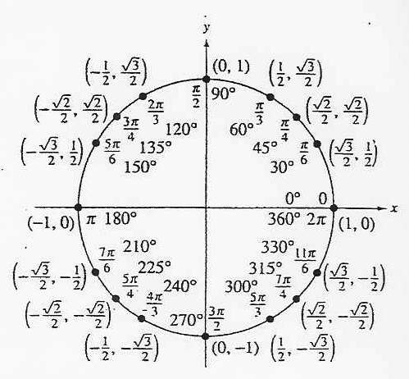

Products and Quotients in Trig Form
If and , hen

DeMoivre’s Theorem
If is a complex number in trigonometric form and n is an integer, then

Dot Product Theorem
If is the angle between two nonzero vectors and , then

The Projection of onto is the vector

