CAREERS IN GEOGRAPHY
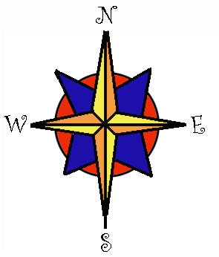
Geography is an extremely exciting and wide ranging field of study. Whether focusing on the human, physical or technical fields geography graduates go on to rewarding careers and enriched lives. While there aren't many job titles that are "geographer," there are many types of positions that fit well with a degree in geography.
Geography is a very attractive major for today's students. The field provides marketable skills and the broad perspectives on environment and society that enable graduates to move beyond entry-level positions. As a major geography builds a sound and unique foundation for students who plan to enter the world tackling issues ranging from climate change to international relations to computer assisted spatial analysis. Geographers also find their skills useful and sought after by employers from fields including business, law, medicine, politics and much more.
Read on to find out about the specific subfields of geography, a small sample of the job titles geographers may find themselves in, an explanation of the requirements of a geography degree at Grossmont College, and helpful links to further information. (Visit the website http://www.grossmont.edu/scotttherkalsen/GeoJobs.htm for more info and electronic links)
PHYSICAL GEOGRAPHY
Geography has a strong link to the natural sciences through physical geography. Courses that may be offered in this field include climatology, meteorology, oceanography, geomorphology (landforms), soils, biogeography (distribution and ecology of plants), zoogeography (distribution and ecology of animals), and natural resource management. Courses in physical geography importantly integrate earth processes with the human use of the earth. For instance, examining agriculture in relation to its dependence upon such physical processes as climate, weather, and the formation and erosion of soils.
Those with a good background in physical geography are well prepared to deal with issues of climatology, resources management, environmental regulation and research, emergency management and more. Physical geographers also study the impact of such natural hazards as hurricanes, tornadoes, volcanic eruptions, and earthquakes.
HUMAN AND CULTURAL GEOGRAPHY
This concentration focuses on the aspects of geography that relate to different cultures, with an emphasis on cultural origins and movement and the cultural characteristics of regions (e.g., language, religion, ethnicity, politics, historical development, agricultural methods, settlement patterns, and quality of life). Cultural ecology--the ways in which humans have interacted with their cultural and natural environment at various times--is also included.
Cultural geographers often try to reconstruct past environments, and to do so they must be equally skilled in library research, field observation, and the interpretation of cultural artifacts. Historical geographers are interested in recreating the geography of past times.
Courses in this area include historical geography, cultural geography, cultural ecology, human geography, human use of the earth, and humanity and nature. Many cultural and human geographers are area specialists as well, which means that they focus their attention on a specific region, such as Latin America, Europe, or Asia. They become area experts and come to understand the way of life in particular countries. They often complement their major courses in a foreign language, anthropology, history, economics, or comparative political systems. Having done so, they bring real expertise and understanding to issues of U.S. foreign policy and to international business

ECONOMIC GEOGRAPHY
Economic geography is concerned with the location and distribution of economic activity. It focuses on the location of industries and retail and wholesale businesses, on transportation and trade, and on the changing value of real estate. Courses in economic geography may cover such topics as transportation, agriculture, industrial location, world trade, and the spatial organization and function of business activity. Students who have a strong interest in economic geography will be likely to see global interdependence as a focus of their academic program.

URBAN AND REGIONAL PLANNING
Geographers often work as planners to ensure that communities develop in an orderly way, along with the services necessary to support them. Planners must be able to develop building plans for subdivisions and housing projects. They need to understand all factors that affect the value of land and real estate. Planning is a rapidly expanding field, and geographers are filling a great many jobs. Planning courses teach students how to prepare master plans that will benefit neighborhoods, communities, cities, and regions. Support courses include material on the geography of population, transportation, social services, utilities, and solid-waste disposal systems. Other topics include resource planning, land-use planning, and the delivery of municipal services (which involves the planning of police patrol routes, the location of firehouses and emergency medical services, and ways of making school bus routes shorter and more efficient).

TECHNICAL GEOGRAPHY
Thousands of geographers have jobs involving maps. Maps are essential. They are used by planners, engineers, utility companies, state agencies, construction companies, surveyors, architects, and ordinary citizens. One of the greatest growth areas is the use of computers to generate maps and store map-related information. Geospatial technologies (geographic information systems, computer mapping, GPS, etc.). is a high-growth industry and reaching $35 billion in annual revenues in 2007, up from $5 billion in 2002. Geospatial technologies are one of the three biggest emerging fields identified by the Department of Labor, and they are providing 75,000 new job hires per year. A student with these unique technical skills is marketable in every field and industry.

The potential for practicing geography in private enterprise and government has grown considerably in recent years, although often such positions are not designated with the title of geographer. Many geographers work in the private and public sectors, below is a list of positions held by geographers:

Air Pollution Specialist
Air Quality Analyst
Air/water quality control
Airline Marketing Executive
Airlines Researcher
Appraiser for a real estate
Archives Manager
Area Specialist
Avalanche Specialist
National Forest Service
Biography Creator
Biologist (consulting )
Budget Planning and City Policy Manager
Business Analyst
Business/Industry
CAD Operator
Career Counselor
Cartographer
Cartographer
Cartographic Technician
City Manager
Clergy
Climatologist
Coastal Zone Manager
College Administrator
College Professor
Colonel in the U.S. Army
Community developer
Computer mapper
Computer programmer
Computer Specialist for a U.S. National Park
Conservation Education Coordinator
Customs Port Investigator
Insurance Data Analyst
Data Processor
Demographer
Department of Agriculture
Departmental Historian
U.S. National Science Foundation
Computer Assisted News
Director of Industrial Development
Planning and Zoning
Earth Scientist
Ecologist
Economic Developer
Economist
Energy Analyst
Engineer, Civil
Engineer, Consulting
Environment Planner
Environmental Impact Analyst
Environmental Manager
Environmental Scientist
Exhibit Artist
Field Data Specialist
Foreign Service Officer
Genealogist
U.S. Defense Mapping Agency
Geographer at the Smithsonian Institution U.S. Bureau of the Census
Geographer at the U.S. Department of Agriculture
U.S. Economic Dev. Adm.
U.S. EPA
NOAA
Water management
Army Corps of Engineers
Army Topographic
Forest Service
Geographer Park Ranger
Geographer, Consulting
U.S. Department of State
Geomorphologist
National Biological Service
Geophysicist Petrologist
Geopolitical Specialist for a software corporation
GIS Analyst in a corporation
GIS county Coordinator
GIS Environmental Coordinator
GIS Database Management
GIS Implementation
GIS/GPS
Government Agency
Hazardous waste planner
Health Services planner
Historian
Hotel Concierge
Housing Planner
Human Service Positions:
Hydrologist
Soil and water conservation
Industrial developer
Industrial planner
Insurance Agent
Insurance Analyst
Intelligence agent
Intelligence Analyst Interpretation Center
International Business Representative
International Economist
International Investment Analyst
International Law and Relations Researcher
Journalist
Land developer
Land Economist
Land Scientist (Consulting)
Land Surveyor
Land Use Planner for a city
Landscape Architect
Lawyer
Legislative Aide
Librarian
Loan Administrator
Location Analyst
Management Trainee
Manpower Planner
Map Analyst
Map Creator
Map Curator
Market Development
Market Research Analyst
Meteorologist at the U.S. National Weather Service
Meteorologist, Television
Museum Curator
Natural Historian, U.S. Soil Conservation Service
Natural Resource Manager
Naturalist Surveyor
Organizational Planner
Peace Corps Volunteer
Personnel Officer
Physical Scientist at USGS
Physical Scientist U.S. Defense
Planner, Community
Planner, County
Planner, Resources
Planner, Transportation
Planner, Urban
Planning, Social,
Planning, economic, Planning, environmental
Import/export
Demography
Public health
Environmental justice
Sustainability
NGOS
Social mobilization Community-building
Resource specialists
Education
Global justice initiatives
Planning Info. Director
Policy Evaluator
Policy Researcher
Political Analyst
Political Scientist
Politician
Pollution Control Specialist
Preservation Specialist
Property manager
Public Info. Coordinator
Public Opinion Pollster
Public Relations
Ranger- U.S. National Park
Real Estate Agent/Broker
Real Estate Research
Recycling Coordinator Redevelopment Coordinator
Regional Environmentalist Regional Planner
Remote Sensing Analyst
Research Meteorologist, U.S. Climatic Data Center
Research Scientist
National Weather Service
Research/Technical Advisor (Film/TV)
Bureau of Indian Affairs
Resource Economist
Risk Analyst
Sales Campaign Planner
Sales/Marketing
Seismologist
Site Researcher
Social Services
Soil Conservationist
Statistician
Stereo Plotter
Topographic Engineer
Surveyor
Systems Analyst
Teacher
Technical Sales Rep.
Technical Writer
Terrain/Land Use Planner
Tour Guide
Tourism Developer
Traffic Management
Transportation analyst
Travel agent/specialist
Travel Consultant
Department of Ag.
Urban Planner
Urban Regional planner
Water & Natural Resources
Water Conservation
Water Quality Spec
Weather forecaster
Wetlands Conservation Reclamation authority
Zoning Administrator
Inspector for a township
Zoning Inspector for a city

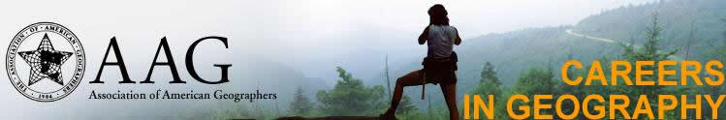
*Job descriptions, advice and explanations from working geographers, future contacts, internships and positions: https://communicate.aag.org/eseries/scriptcontent/custom/giwis/cguide/job.cfm or (aag.org)
Work for the United States Geologic Survey: www.usgs.gov

Search for current job openings in the field of geography: http://www.geographyjobs.com/
GIS jobs clearinghouse: http://www.gjc.org/
GIS, GPS, Remote Sensing, Image Processing, Computer Science: http://www.geosearch.com/
Jobs in geoscience, geography, environmental, agriculture, forestry, ecology, meterology, oceanography, hydrology, soil, GIS and related subjects: http://www.earthworks-jobs.com/
Environmental jobs and careers: http://www.ejobs.org/
More GIS jobs: http://www.gisjobs.com/

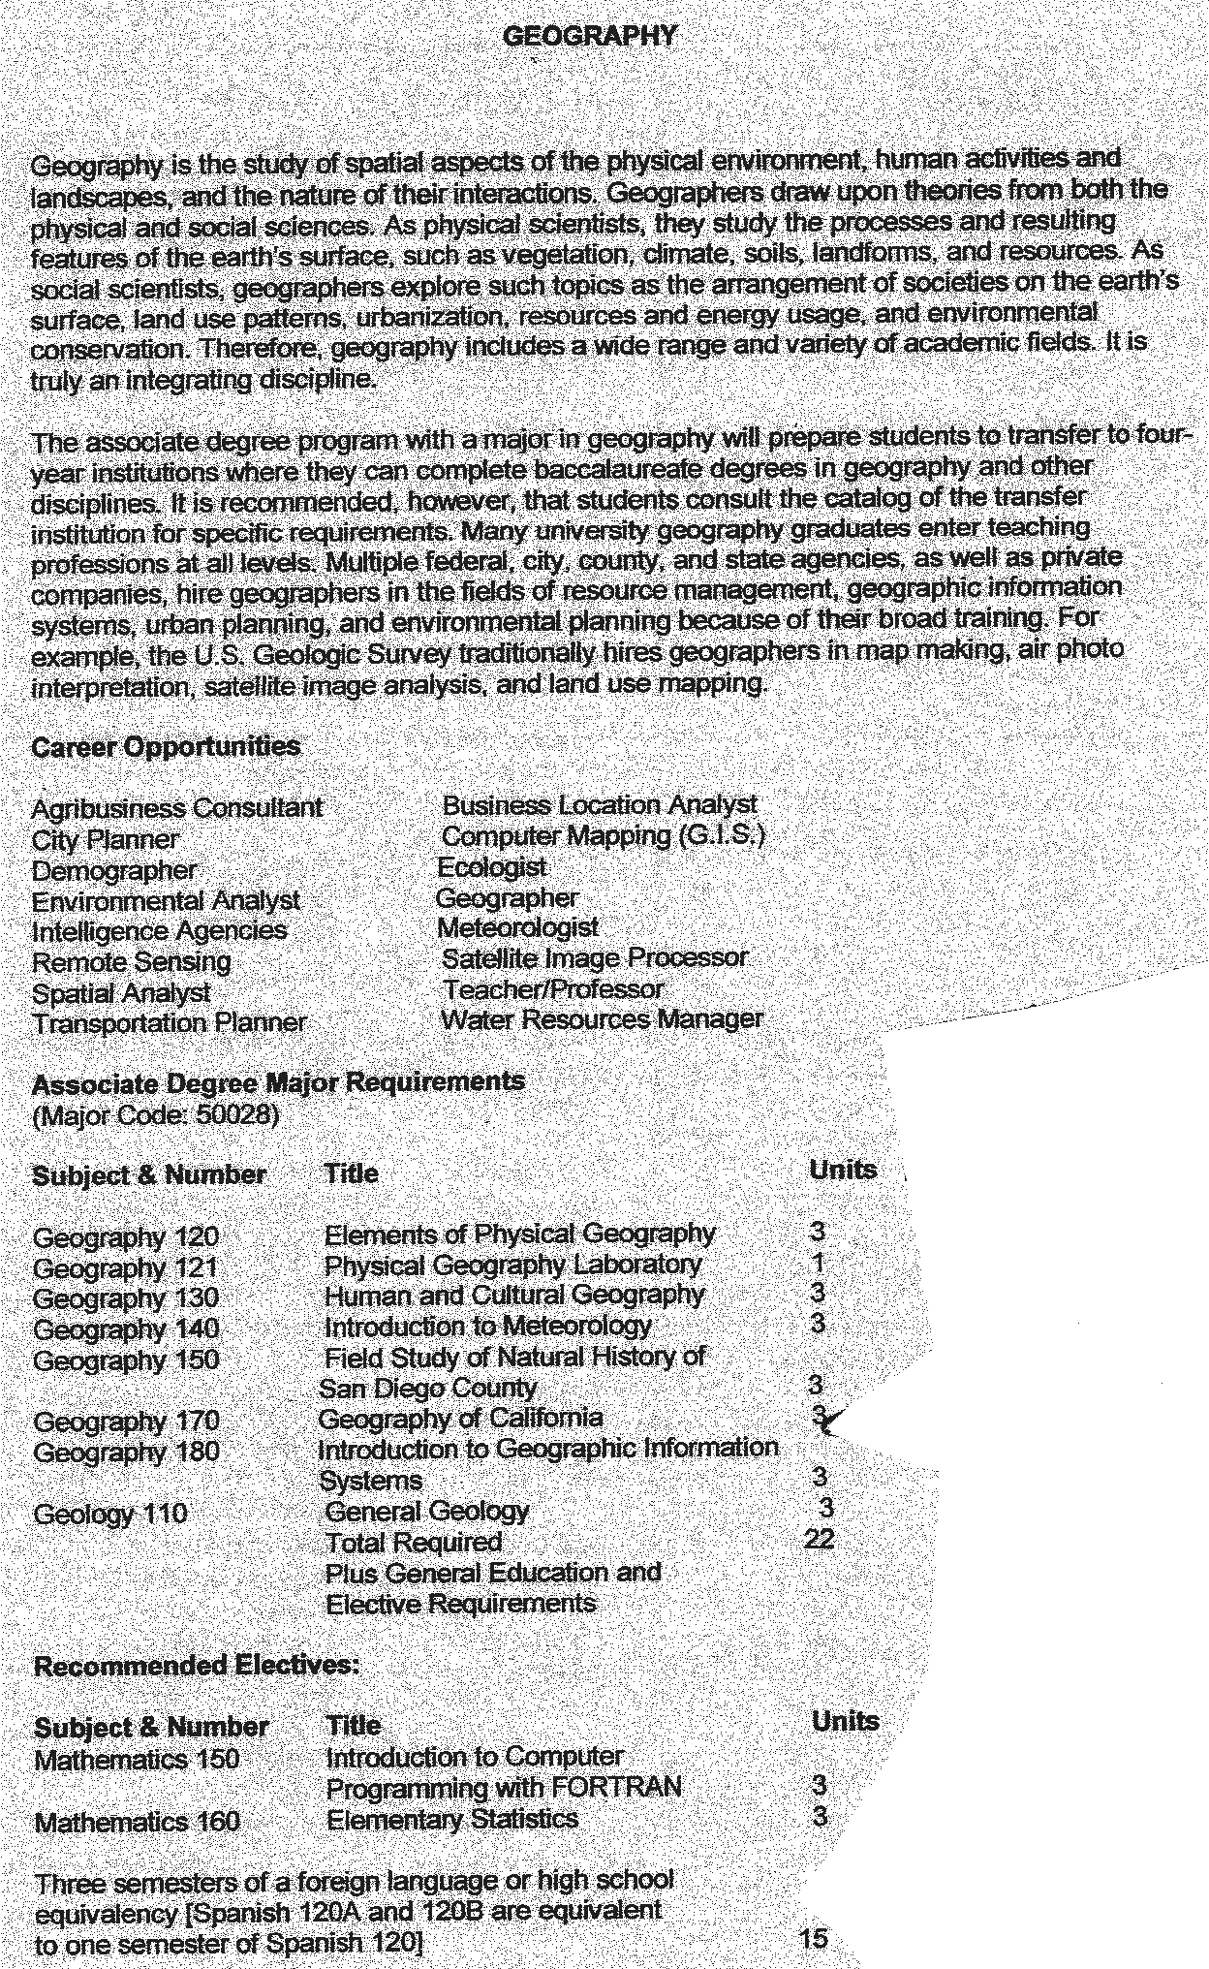
GEOGRAPHY AT GROSSMONT COLLEGE

