Physical Geography 120

Course Syllabus

Geography Department
Grossmont College
Fall 2014

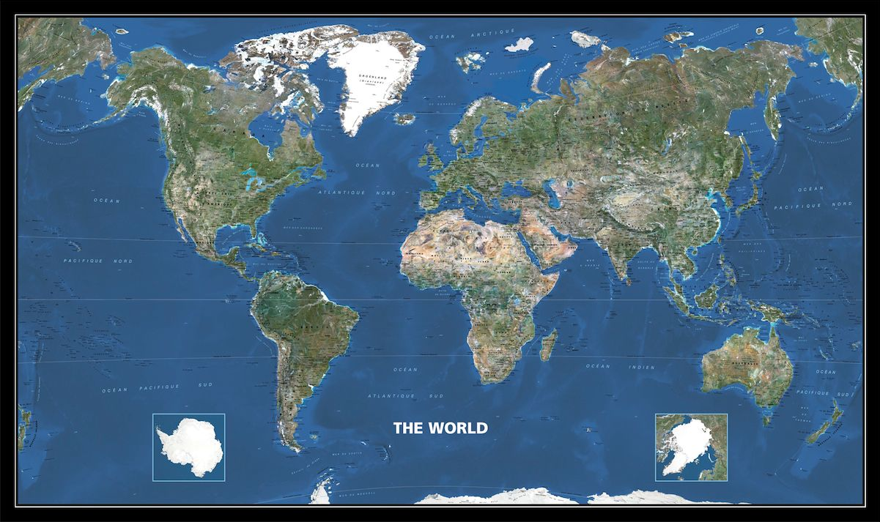

Instructor: Scott Therkalsen
E-mail: scott.therkalsen@gcccd.edu
Class Website: www.grossmont.edu/scotttherkalsen
Class meets: T/Th 2:00-3:20 in Room: 36-355
Office Hours: Tues 3:30-7:00; Wed: 11-12:30 Thurs 11:30-12:30 and by appointment
Office: Building 37 room 300-A4
Phone: (619) 644 7358

REQUIRED TEXT and MATERIALS:
- Textbook: Alan Strahler and Arthur Strahler. 2005. Physical Geography: Science and systems of the human environment. 3rd edition. ISBN: 0-471-48053-3
- A 3 ring binder
- Colored Pencils
- Internet Access: Students are required to have access to the internet for this course. Utilizing this physical geography online webpage is a vital tool for success:
www.grossmont.edu/scotttherkalsen
**If you need assistance accessing a Grossmont College internet account contact your instructor at the beginning of the course

Suggested text:
Veregin, Howard. 2005 (or newer). Goodes’s World Atlas. Latest Edition. Rand McNally and Company.

CATALOG COURSE DESCRIPTION:
“Explore your world! This physical science course examines and explains the earth’s major physical systems, the basic energy and material flows by which these systems operate, and the result of human interaction with these flows. Phenomena explored include storms, climate, ecosystems, seasonal change, plate tectonics, stream and glacial activity, and beach systems.”
Satisfies General Education for: Grossmont College B2, CSU B1, IGETC 5A. Transfers to CSU, UC (CAN GEOG 2)
STUDENT LEARNING OUTCOMES: Mastering the topics above will enable you to:
1. Students should be able to memorize, apply, and explain the rationale behind classification systems developed for recognizing, explaining, and predicting relationships, patterns, and trends in Earth Systems (e.g., classification of rocks; classification of thermal vs. dynamic weather systems; forms of energy, classification of climates in terms of the availability of the inputs to photosynthesis; classification of biomes, etc.).
2. Students should be able to describe, apply, and explain the evidence behind the foundational scientific models commonly used to explain and predict relationships, patterns, and trends within Earth Systems (e.g., Copernican Model describing Earth-Sun relationships; Kinetic Theory, Thermodynamics, Plate Tectonic theory; etc.).
3. Students should be able to explain the step-by-step causes and outcomes of thermal circulation within the Earth System, including across various spatial and temporal scales (e.g., Sea Breezes vs. Monsoonal Wind Systems vs. Hadley Cells; Plate Tectonics; etc.).
4. Students should be able to discuss the unique characteristics and importance of water within the Earth System (e.g., heat storage; latent heat; gradational work performed by streams, waves, and glaciers producing erosional vs. depositional landforms; etc.)
ASSIGNMENT EXPLANATIONS:

Exams (63%)
There will be a total of four exams. Each is worth 15% of your final grade. The exams will be a combination of multiple choice, true/false, and short answer questions. The information learned throughout the course builds on itself so that questions on later exams will require a mastery of the topics learned for earlier exams. You should be following along, reviewing and taking practice quizzes online to prepare for the exams. The last exam will include an emphasis on formerly learned key concepts (50%new material and 50% old material). You must bring a “Datalink” form #26760 for each test. There will be no makeup exams given.

Concept Quizzes (10%)
There will be a total of three concept quizzes; one each mid way through the first three sections of the course. These are short (15 question) true/false, multiple choice quizzes designed to help encourage you to be actively reviewing the material from your class notes and the readings. You must bring a “Datalink” form #26760 for each quiz. There will be no makeup quizzes given.

Map Quizzes (18%)
There will be a total of four map quizzes. Each one will ask you to name 20 countries or physical features from a certain region. They will cover the Western Hemisphere, Africa, Europe and the Middle East, and Asia respectively. They will be worth 4.5% each for a total of 18%. There will be no makeup quizzes given.

Explanatory Essays (9%)
There will be two assigned essays in which you will be expected to thoroughly and clearly explain a major concept integrating all of the recently learned course information.

EXTRA CREDIT
Extra credit can be obtained by answering all of the study guide questions for the first 3 sections of the course (5 points for each section for a total of 15 extra credit points). You must rewrite and fully answer each question on a separate sheet of paper. These questions will be collected on the day of each test. Points will be awarded based upon the correctness of the answer, amount of detail of each answer and full explanation of “why” questions and causal relationships.

ASSESSMENT BREAKDOWN:
Assessment was created to provide students with different abilities the opportunity to demonstrate their knowledge in a variety of manners.
Assignment Points Possible % of Total Grade
Map Quiz One 20 points 4.5%
Map Quiz Two 20 points 4.5%
Map Quiz Three 20 points 4.5%
Map Quiz Four 20 points 4.5%
Map Quiz Totals 80 points 18%
Concept Quiz One 15 points 3.3%
Concept Quiz Two 15 points 3.3%
Concept Quiz Three 15 points 3.3%
Concept Quiz Totals 45 points 10%
Explanatory Essays 40 points 9%
Exam One 70 points 15%
Exam Two 70 points 15%
Exam Three 70 points 15%
Exam Four *(Check Date) 70 points 15%
Exam Totals 280 points 63%
Total Points Possible 445 points 100%
MQ1_____ + MQ2_____ + MQ3_____ + MQ4_____ + CQ1_____ + CQ2_____

+ CQ3____ + E1_____ + E2_____ + E3_____ + E4_____ + EE1 ______+ EE2_____=______/445

*You should also track you grades through the website: www.eclassinfo.com
(ID# = student number and password = 6 digit birthday)
Grading Scale
A 90-100% 400 points and up
B 80-89% 356-399 points
C 70-79% 311-355 points
D 60-69% 267-310 points
Failing 59% and below below 267 points
Credit/No Credit 68-100% for credit 303 points and up
GENERAL POLICIES:
Attendance and Behavior
Inappropriate behavior of any kind in the classroom will not be tolerated. You are expected to come to every class prepared and ready to work. Students may be dropped from class for failure to attend the first week or for excessive absences. If necessary it is your responsibility to officially withdraw from the course before the final drop deadline.
The most important strategy for succeeding in this course is to come to class eager to learn, participate and critically think. There will be no makeup quizzes or exams. No late assignments will be accepted. As adults you are expected to respect your classmates by coming to class on time, acting appropriately and refraining from using any electronic devices during class; students with cell phones visible during class will be asked to leave (voice recorders and electronic translators may be used with permission but no electronic translators may be used during tests).

Preparation for Class
Students should always bring a pencil/pen, colored pencils, 3 ring binders and their textbook to every class meeting. Readings listed in the course schedule should be completed prior to the class meeting and prior notes should be reviewed and questions generated prior to each class meeting. The class website should be visited weekly and the current lecture topic should be reviewed. These actions will insure that you will be well prepared to actively participate in discussions and class activities.

Students with Disabilities
“Students with disabilities who may need accommodations in this class are encouraged to notify the instructor and contact Disabled Student Programs and Services (DSPS) early in the semester so that reasonable accommodations may be implemented as soon as possible. Students may contact DSPS in person in Room 110 or by telephone at (619)644-7112 or (619)644-7119 (TTY for deaf).”

Behavior and Academic Integrity
“Cheating and plagiarism (using as one’s own ideas, writings or materials of someone else without acknowledgement or permission) will result in any one of a variety of sanctions. Such penalties may range from an adjusted grade on the particular exam, paper, project or assignment (all of which may lead to a failing grade in the course) to, under certain conditions, suspension or expulsion from a class, program or the college. For further clarification and information on these issues, please consult with your instructor or contact the office of the Associate Dean of Student Affairs.”

Supervised Tutoring Referral
Students are referred to enroll in the following supervised tutoring courses if the service indicated will assist them in achieving or reinforcing the learning objectives of this course:
English 198W, Supervised Tutoring for assistance in the English Writing Center (Room 70-119); and/or IDS 198T, Supervised Tutoring to receive one-on-one tutoring in academic subjects in the Tutoring Center (Room 70-229, 644-7387).

CLASS SCHEDULE
*This is only a tentative schedule; you will be notified of any changes as they occur throughout the semester
DATES | CONCEPTS | STAHLER² 3rd EDITION READINGS | ASSIGNMENTS/ ASSESSMENT
08/19/2014 | Introductions What is Physical Geography?
08/21/2014 | The geographic grid | Pgs. 35-48
08/26/2014 | The Underpinnings of Physical Science
08/28/2014 | Foundational Laws
09/02/2014 | Earth-Sun relationship | Pgs. 49-54 | MAP QUIZ ONE
09/04/2014 | Radiation Laws and Insolation | Pgs. 63-75
09/09/2014 | The Atmosphere | Pgs. 75-81 | CONCEPT QUIZ ONE
09/11/2014 | Sensible Heat and Latent heat | Pgs. 81-89
09/16/2014 | Global Energy Budget  (Air Temp)
09/18/2014 | TEST # ONE | STUDY! | TEST # ONE
09/23/2014 | Air Temperature | Pgs. 101-107
09/25/2014 | Temperature and Wind | Pgs. 110-122
09/30/2014 | Wind and Atmospheric pressure | Pgs. 169-181 | Seasons Essay Due
10/02/2014 | Global Winds | Pgs. 181-192
10/07/2014 | Moisture and Humidity |  | MAP QUIZ TWO
10/09/2014 | Clouds | Pgs. 135-146
10/14/2014 | Forced Lifting | Pgs. 146-153 | CONCEPT QUIZ TWO
10/16/2014 | Traveling Weather Systems | Pgs. 205-227
10/21/2014 | TEST TWO | STUDY | TEST TWO
10/23/2014 | Climate | Pgs. 233-243
10/28/2014 | Global Climate | Pgs. 243-248  Skim Ch. 10/11
10/30/2014 | Climate and the Biosphere | Pgs. 639-649 | MAP QUIZ THREE
11/04/2014 | Global Vegetation and Earth Materials
11/06/2014 | Rocks | Pgs. 329-345 | SD Climate Essay Due
11/11/2014 | NO SCHOOL |  | NO SCHOOL
11/13/2014 | Plate Tectonics | Pgs. 355-380 | Concept Quiz Three
11/18/2014 | Tectonic landforms | Pgs. 387-412
11/20/2014 | Exogenous Work | Skim Chapter 15 &17
11/25/2014 | TEST THREE | STUDY | TEST THREE
11/27/2014 | NO SCHOOL |  | NO SCHOOL
12/02/2014 | Ocean Composition
12/04/2014 | Tide and Waves |  | MAP QUIZ FOUR
12/11/2014 | Final Exam 1:45-3:45 |  | FINAL EXAM

