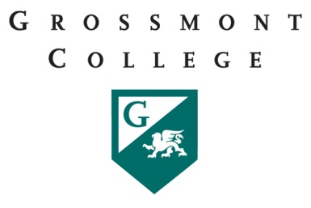

Grossmont College
Academic Senate Meeting
Monday, October 17, 2016
11:00am – 12:20pm in Griffin Gate

- CALL TO ORDER
  - Public Comment – Each speaker will be given a maximum of 4 minutes to address the senate about a non-agenized item or items, with a maximum of 15 minutes allowed for public comment. The senate may vote to extend public comment at any meeting. Please contact the senate secretary before the meeting when wishing to speak at public comment. The senate welcomes all speakers to participate in the discussion on agendized items.
  - Approval of Agenda
  - Approval of Minutes from August 29, 2016
II. PRESIDENT’S REPORT
- Enrollment Update
- Campus Conversations
- Alliance Retreat
- Fall Preview
- Single Plan for Categoricals

- COMMITTEES
- Program Review (Handbook)
- ACTION ITEMS
- INFORMATION ITEMS*
- Facilities Master Plan Refresh
- Online Class Max Resolution

*The Academic Senate may move information items to action upon a 2/3 vote.

{Section 5. Quorum“A simple majority of Senators including Senator designees recognized by the Chair at the openings of meetings shall constitute a quorum. Senator positions not filled by departments will not be includ
quorum determination.” Average number of senators attending the first three Senate meetings, Fall, 2011: 54}

