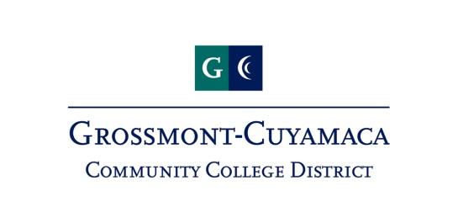

JOINT ACADEMIC SENATE AGENDA
Thursday January 25, 2018, Room I-209, 10:00am – 12:00am
THE JOINT ACADEMIC SENATE
- State of the District: Dr. Cindy Miles
- Compressed Calendar
- Online College: the proposed 115th Community College

