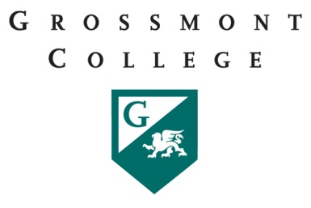

Grossmont College
Part-Time Faculty Committee
Monday, October 24, 2016
11:00am – 12:20pm in 53-553

AGENDA ITEMS
 | DISCUSSION ITEMS | FOLLOW UP ACTION | COMMUNICATION
1 | Update on Senate Resolution re:PT OH..Make a report to the Senate
2 | Report on Tuesday's meeting of President w/ Chairs regarding scheduling
3 | The need for an open email distribution list (DL) like at other colleges.
4 | "All In" Campaign - Surveys and experiences?
5 | PT Pay for Committee work - Procedures and update
6 | East Education Alliance
7 | Other

