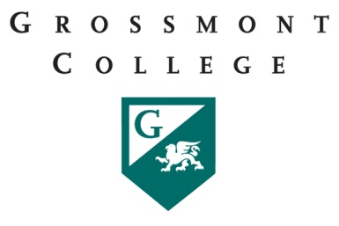

Grossmont College
Part-Time Faculty Committee
Monday, November 28, 2016
11:00am – 12:20pm in 53-553

AGENDA ITEMS
 | DISCUSSION ITEMS | FOLLOW UP ACTION | COMMUNICATION
1 | The need for an open email distribution list (DL) like at other colleges.
2 | "All In" Campaign - Surveys and experiences?  Achieving the Dream (ATD) and PT Faculty
3 | PT Pay for Committee work - Procedures and update  . PT Office Hours.  Review Guild Proposal. PT Equity - Lower pay for committee work and office hours increases the income gap.  AS supports pay equity.
4 | East Education Alliance
5 | Campus Security and PT faculty - Evening and "off hours".
6 | Open Educational Resources (OED)  PT experiences
7 | Announcement:  PT CalSTRS presentation at City College Friday December 2nd 10:30am-3pm w/Lunch

