Lab 10

**Conversion between Fractions and Decimals**

Equipment: Four-function calculator with memory

1. 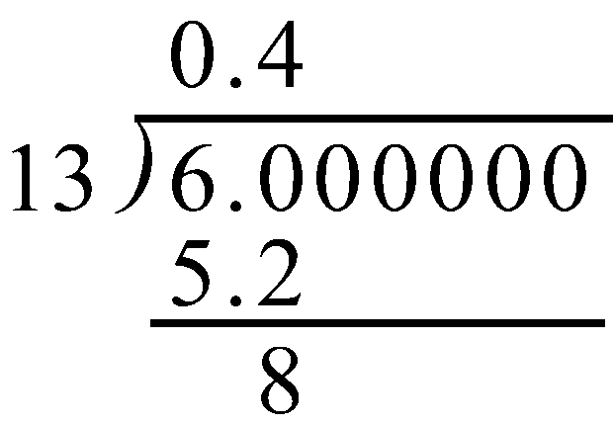Fractions as repeating decimals.  
    a) If we want to express  as a decimal, we have to go through the following long division. And at each step, pay attention to the remainder (disregarding the decimal point). Stop when you see the same remainder appears again.  
     
     
     
     
     
     
     
     
     
     
     
     
     
     
     
     
     
     
     
    b) What are the possible “remainders” obtained above? (“remainder” means the number   
    you get after subtraction, disregarding the decimal point.)  
      
     
    c) Now continue the above long division for two more steps. Do you notice that   
      
    you are doing something that you have done before? _____________  
     
    Do you notice that the digits in the quotient start to repeat themselves? ________  
    What do you think the decimal expansion of  would be? ____________________

Let us do it one more time and convert $\frac{9}{13}$ into a repeating decimal.

)

13 9.0 0 0 0 0 0 0 0

What are the possible “remainders” obtained above? (“remainder” means the number   
 you get after subtraction, disregarding the decimal point.)  
  
 _________________________________________________________________  
  
 c) Now continue the above long division for two more steps. Do you notice that   
   
 you are doing something that you have done before? _____________  
  
 Do you notice that the digits in the quotient start to repeat themselves? ________  
  
 What do you think the decimal expansion of $\frac{9}{13}$ would be? ____________________

d) In general, if we have to convert  into a decimal by long division, what are the possible remainders (including 0) that we will encounter in the long division process?   
  
 _______________________________________________________________.  
  
 e) If the decimal expansion of  does not terminate, that means that the remainder is never _______. In this case we have to continue the division process forever. But there are   
  
only ________ possible remainders, so sooner or later we will see the same remainder twice   
  
and the whole division process will repeat itself. This implies that the decimal expansion must be repeating, and the length of the repeating pattern for  is at most ________.  
 f) Using the same argument as above, if the decimal expansion of  (for any whole number *c*) is not terminating, it must be _________________, and the length of its pattern is   
  
at most _________ digits.  
  
 g) If the decimal expansion of  is not terminating, it must be _________________, and the length of its pattern is at most _________ digits. This is true whenever the denominator is a prime number.

1. This time we have to do the opposite – converting repeating decimals to fractions.  
     
   a) Use your experience to find the decimal expansion of $\frac{1}{3}$. ______________  
     
   b) Guess what (0.3333 …) ÷ 3 is (in decimal form)? _____________   
     
    What is $\frac{1}{3}÷3$ as a fraction? _______________   
    If so, what will be the decimal expansion of $\frac{1}{9}$? _____________  
     
   c) Can you guess what is 5 × 0.111111 … ? ______________  
     
    What is $5×\frac{1}{9}$ as a fraction? ______.   
     
    Guess what fraction has decimal expansion of 0.555555…..? ___________  
      
     
   d) Guess what fraction has decimal expansion of 0.77777…..? ____________  
     
   e) Can you convert 0.999999……. into a fraction and simplify your answer.   
      
    ________________. Are you surprised with your answer? ____________  
     
   f) Use your calculator to find out the decimal expansion of 1/99. ______________  
     
    Use your calculator to find the decimal expansion of 17/99. ______________  
     
    Predict the decimal expansion of 45/99 _____________________  
     
    Convert the decimal 0.686868… to a fraction __________________  
     
   g) Predict the decimal expansion for 1/999 ________________________  
     
   h) Use calculator to find the decimal expansion of 283/999. _____________________  
     
    Do the same for 377/999. _____________________________  
     
   i) Do you see a pattern? _________. If yes, convert 0.518518518 … into a   
     
    fraction. _________________

j) Convert $\frac{4}{9}$ into a decimal. ___________________  
  
 Convert $\frac{4}{90}$ into a decimal. ___________________  
  
 Convert $\frac{4}{900}$ into a decimal. ___________________  
  
 Convert $\frac{4}{9000}$ into a decimal. ___________________  
  
 Do you see a pattern? __________  
  
  
k) Convert 0.28282828…. into a fraction. ______________  
  
 Convert 0.028282828 … into a fraction. ______________  
  
 Convert 0.0028282828 … into a fraction. ______________  
  
  
  
l) Convert 0.421421421 … into a fraction. ______________  
  
 Convert 0.0421421421 … into a fraction. ______________  
  
 Convert 0.00421421421 … into a fraction. ______________

1. m) Convert 0.2464646…. into a **single** fraction. ____________________  
    (*show work here*)  
      
     
     
     
     
     
     
    Convert 0.1234234234… into a **single** fraction.______________________  
    (*show work here*)

Convert 0.4217217217… into a **single** fraction.______________________

(show work here)  
  
  
  
  
  
  
  
  
  
  
 From the above three exercises, can you find out a short-cut to convert these   
 repeating decimals into fractions? ___________  
  
 If yes, explain how to use your short cut to convert 0.31285285285… into a   
 fraction. Check your answer with a calculator.  
  
  
  
 Ans: ______________________________________________________

______________________________________________________

1. We know that all rational numbers have repeating (which also includes terminating) decimal expansions. On the other hand, numbers with non-terminating and non-repeating decimal expansions are called irrationals, typical examples are   
     
    π = 3.141592653… and  =1.414213562…   
     
   One easy way to create a non-terminating and non-repeating decimal is to insert more and more zeros as we go on, such as 0.101001000100001… or 0.23023002300023…  
     
   Add a tail to 2.71828 to make it irrational. 2.71828 ________________________ .  
     
   We can use this method to insert irrational between two repeating decimals - no matter how close they are to each other.  
     
   For example, between the repeating decimals 0.784748784… and 0.785785785… we can insert the irrational 0.7852101001000100001…..  
     
   The first part (i.e. 0.7852) ensures that this number is between the two given ones. It will be more obvious if we write them in the following form  
    0.784748784…  
    0.7852  
    0.785785785…   
   The beauty in the ordering of decimals is that no matter what digits we attach to the end of 0.7852, the new number is still between the two given numbers. We therefore have the freedom of adding whatever "tail" we like to 0.7852 and make it irrational.  
     
   The "tail" we add has to be (of course) non-terminating and non-repeating, such as  
    101001000100001⋅⋅⋅  
     
   This explains why 0.7852101001000100001⋅⋅⋅ is a correct answer, but there are of course many other possible choices.  
     
   a) Find 3 irrational numbers between the two rational numbers   
     
    0.536536536⋅⋅⋅ and 0.537537537⋅⋅⋅  
     
    _____________________, ___________________, _____________________  
     
   b) Find 3 rational numbers between the two irrationals   
     
    0.24224222422224…… and 0.25225222522225….  
     
    _____________________________________________________________________