Exam 2

Part 1: Multiple Choice (2 points each)

Directions: Please circle the best answer for each of the following questions.

- Which picture best represents an atomic-level view of hydrochloric acid, which is a strong acid, in aqueous solution (water molecules not shown)?
  - 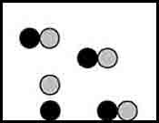 c. 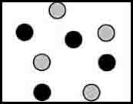
b. 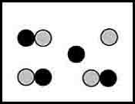 d. 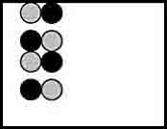

- The thermite reaction is used in welding applications and chemistry demonstrations because it releases a tremendous amount of energy. Which of the following statements is not correct regarding this reaction?
8Al + 3Fe₃O₄ → 9Fe + 4Al₂O₃
  - Aluminum is oxidized.
  - Iron is reduced.
  - The oxidation number of Al changes from 0 to +3.
  - Aluminum is the reducing agent.
  - Three electrons are transferred from each aluminum atom to each iron atom.

- In which one of the following compounds is the oxidation number of S equal to +4?
  - H₂S
  - Na₂SO₃
  - S₈
  - S₂Cl₂
  - MgSO₄

- Heat is best defined as ________
  - a substance that increases the temperature and causes water to boil.
  - energy transferred as the result of a temperature difference.
  - a form of potential energy.
  - a form of work.
  - the total energy that a substance has.

- Which substance has an enthalpy of formation equal to zero at 25ºC and 1 atm?
  - N_{2 (g)}
  - N_{2 (l)}
  - N_{2 (s)}
  - N _{(g)}
  - N _{(s)}

- Which statement regarding combustion of a sample of gasoline in a bomb calorimeter is correct?
  - Work is done by the system on the surroundings.
  - Work is done by the surroundings on the system.
  - No work is done because the volume cannot change.
  - The work done by the system equals the energy produced by the system.
  - The experiment provides a very accurate value for the enthalpy of combustion of gasoline.

- Which set of gases is listed from slowest to fastest effusion rate?
  - N₂O < NO₂ < NO < N₂O₄
  - NO < N₂O < NO₂ < N₂O₄
  - N₂O₄ < NO₂ < N₂O < NO
  - NO < NO₂ < N₂O < N₂O₄
  - N₂O₄ < N₂O < NO₂ < NO

- In a mixture of gases, the gas with the largest mole fraction will have the ________
  - largest molar mass.
  - smallest molar mass.
  - largest number of molecules present.
  - smallest number of molecules present.
  - highest kinetic energy.

- Which of the following is unimportant when using the ideal gas law?
a. The chemical identity of the gas sample.
b. The temperature of the gas sample.
c. The pressure of the gas sample.
d. The volume of the container holding the gas sample.
e. The amount of gas.

- To make up a lab experiment you should
  - inform your instructor.
  - email the instructor in the class you want to make up the experiment for permission.
  - inform the stockroom.
  - all of the above
  - none of the above

Part 2: Short Answer

Directions: Answer each of the following questions. Be sure to use complete sentences where appropriate. For full credit be sure to show all of your work.
- Answer the following questions about the unbalanced redox reaction (15 points):

PbS _{(s)} + H₂O_{2 (aq)} PbSO_{4 (s)} + H₂O _{(l)}
  - Determine the oxidation number on each atom in the reaction.

  - Identify the element oxidized, element reduced, oxidizing agent, and reducing agent.

  - Balance redox reaction using the half reaction method in acidic conditions.

- Assume that the nutritional content of an apple – say 50 Cal – could be used to light a light bulb. For how many minutes would there be light if a 23 – watt (1 W = 1 J/s) compact fluorescent bulb (8 points)?

- What is meant by the terms solution, solvent, and solute (3 points)?

- Sports trainers use cold packs containing ammonium nitrate for injured athletes (10 points).
NH₄NO_{3 (s)} → NH₄⁺ _{(aq)} + NO₃– _{(aq)} ∆H = 21.1 kJ/mol
  - What is the heat absorbed when 47 g ammonium nitrate dissolves in 100 g water?

  - Calculate the temperature change when 47 g ammonium nitrate dissolves in 100 g water. Assume the specific heat of the solution is 4.5 J/(g ∙ °C).

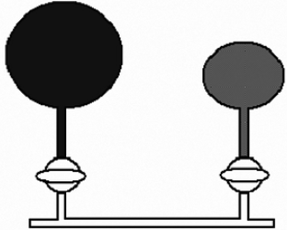
- N₂O (laughing gas) is used as an anesthetic. A dentist has a 2.00 L flask of N₂O at a pressure of 1.00 atm and a 3.00 L flask of nitrogen gas at 2.00 atm that are separated by a valve. Both flasks are at the same temperature, and the temperature does not change when the gases mix (12 points).
- What is the pressure of the laughing gas after the valve is open?

- What is the pressure of nitrogen gas after the valve is open?

- What is the pressure in the flasks when the valve is opened, and the gases mix together?

- A sample of an unknown metal was reacted with 150.0 g of hydrochloric acid in a calorimeter (20 points).
  - If a 2.744 g sample of the metal caused the temperature of the calorimeter and its contents to rise from 22.4ºC to 61.2ºC, calculate the heat of reaction per g for the metal. (The acid solution has a specific heat of 4.168 J/g K, and the calorimeter has a heat capacity of 39.2J/K.)

  - The hydrogen gas from the experiment above was collected in a 397 mL at 30.0ºC and 731 torr pressure, how many moles of hydrogen were collected?

  - What is the molar mass of the metal? (Previous experiments have shown the metal to form a chloride of the formula MCl₃. Write a balanced chemical reaction and determine how many moles of the metal reacted.)

  - Calculate the molar heat of reaction of the metal.

- The diffusion rate of H₂ in a lecture hall was found to be 25.0 m/sec at 25°C. How long will it take poisonous HCN gas to diffuse 10 m in the same room (8 points)?

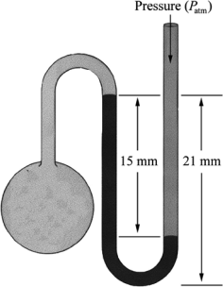

- What is the pressure in the gas bulb connected to the mercury manometer shown in the diagram if the ambient pressure is 750 torr? The heights labeled in the diagram are 15 mm and 21 mm (4 points)

