Exam 3

Part 1: Multiple Choice (2 points each)

Directions: Please circle the best answer for each of the following questions.

- A shell consists of all ________
  - electrons with the same quantum number.
  - orbitals with the same quantum numbers.
  - orbitals with the same principal quantum number.
  - electrons with the same magnetic quantum number.
  - orbitals with the same and m_{l} quantum numbers.

- Which of the following is not an allowed value for the principal quantum number?
  - 0
  - 1
  - 2
  - 3
  - 10

- Atomic spectra are due to the changes in the energy of ________
  - protons.
  - neutrons.
  - nuclei.
  - electrons.
  - electromagnetic radiation.

- Which of the following electron configurations represents an excited state?
  - [Ne]3s²3p⁵
  - [Kr]4d¹⁰5s²5p¹
  - [Ar]3d¹⁰4s²4p⁶
  - [Ne]3s²3p⁶4s¹
  - [Kr]4d¹⁰5s¹5p¹

- Which of the following oxoacids would you predict not to exist?
  - HFO₄
  - HClO₄
  - HBrO₄
  - HIO₄
  - HClO
- What are the hybridizations of the carbon atoms in CH₃CH₂(CO)H, in order from left to right? Note that the C=O bond is a double bond.
  - sp³, sp³, sp²
  - sp³, sp³, sp³
  - sp³, sp², sp³
  - sp², sp², sp³
  - sp³, sp², sp²
- Which of the following substances is a solid at 25°C and 1 atm?

  - 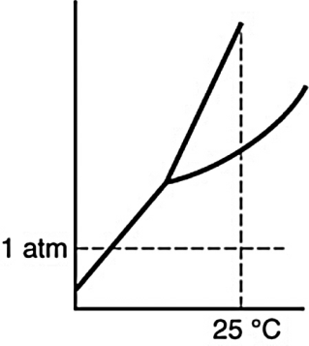
  - 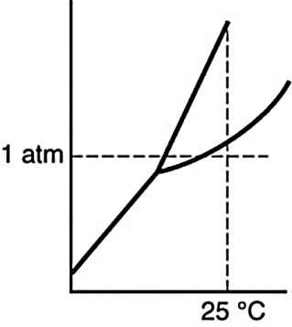
  - 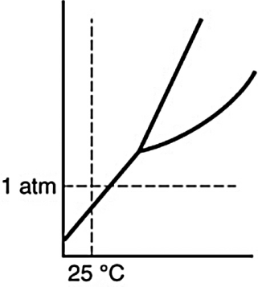
  - 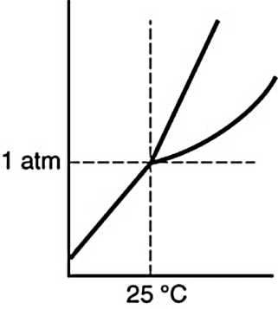

- Which is the dominant interaction between oxygen and nitrogen molecules in air?
  - ion–ion
  - ion–dipole
  - dipole–dipole
  - hydrogen bonding
  - dispersion or London forces

- The vapor pressure of a liquid increases with increasing temperature because ________
  - more molecules can escape from the liquid because their average kinetic energy is greater.
  - the number of gas molecules above the liquid does not change but their average kinetic energy increases.
  - the molecules in the liquid move faster and exert a greater pressure.
  - the ideal gas law states that the pressure is proportional to the temperature.
  - molecules interact less strongly at higher temperatures.

- What are the F-Po-F bond angles in polonium(VI) fluoride?
- 90°
- 109.5°
- 120°
- 180°
- 90° and 120°

Part 2: Short Answer

Directions: Answer each of the following questions. Be sure to use complete sentences where appropriate. For full credit be sure to show all of your work.
- A light detector based on the photoelectric effect is made with cesium metal. Cesium metal has a work function of 3.40 × 10^{–19} J (6 points).
  - What is the longest wavelength in nm of light that one could expect to detect with this device?
$$E=\frac{hc}{λ}⇒λ=\frac{hc}{E}=\frac{\left(6.626×{10}^{-34} J s\right)\left(3.00×{10}^{8}\frac{m}{s}\right)}{(3.40 ×{10}^{-19} J)}×\frac{{10}^{9} nm}{1 m}=585 nm$$
  - What is the frequency of the light?
$$ν=\frac{c}{λ}=\frac{3.00×{10}^{8}\frac{m}{s}}{585×{10}^{-9}m}=5.13×{10}^{14}\frac{1}{s}$$
- Astronomers have detected hydrogen atoms in interstellar space in the n = 732 energy level. Suppose an atom in this excited state emits a photon and undergoes a transition from n = 732 to n = 721 (8 points).
  - How much energy does the atom lose as a result of this transition?
$$∆E=E_{final}-E_{inital}=-2.18×{10}^{-18} J\left(\frac{1}{n_{f}^{2}}-\frac{1}{n_{i}^{2}}\right)$$
$$∆E=-2.18×{10}^{-18} J\left(\frac{1}{{721}^{2}}-\frac{1}{{732}^{2}}\right)=-1.25×{10}^{-25} J$$

  - What is the wavelength of the emitted photon, R_{H} = 1.097 × 10⁷ m⁻¹?
$$\frac{1}{λ}=R_{H}\left(\frac{1}{n_{f}^{2}}-\frac{1}{n_{i}^{2}}\right)$$
$$\frac{1}{λ}=\left(1.097×{10}^{7} m^{-1}\right)\left(\frac{1}{{721}^{2}}-\frac{1}{{732}^{2}}\right)=6.2946594×{10}^{-1}m^{-1}$$
$$λ=1.588648308 m≈1.589 m$$
  - In which spectral region does this radiation lie?_radio frequency region of the spectrum

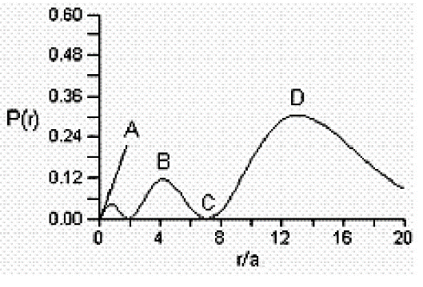
- Consider the radial distribution shown below for an electron in an s atomic orbital where r is the distance of the electron from the nucleus (4 points).
Identify: (1) where the atomic nucleus is located; (2) a radial node; (3) the most probable distance of the electron from the nucleus; and (4) the principle quantum number for this orbital.
(1) The nucleus is located at A; (2) radial nodes are at r/a = 2 and 7 (C); (3) the most probable distance is r/a = 13 (D); (4) and n = 3, because there are two radial nodes.

- Cyanogen is a gas which contains 46.2% C and 53.8% N by mass. At a temperature of 25 °C and a pressure of 750 mm Hg, 1.50 g of cyanogen occupies 0.714 L (18 points).
  - What is the molecular formula of cyanogen?
$$Molar Mass=\frac{mRT}{PV}=\frac{\left(1.50 g\right)\left(0.08206 \frac{L atm}{mol K}\right)(298 K)}{(750 mm Hg)(0.714 L)}×\frac{760 mm Hg}{1 atm }=52.1\frac{g}{mol}$$
$$46.2 g C×\frac{1 mol C}{12.011 g C}=3.846474065 mol C$$
$$53.8 g N×\frac{1 mol N}{14.007 g N}=3.840936675 mol N$$
$$empircal formula=C_{\frac{3.846474065}{3.840936675}}N_{\frac{3.840936675}{3.840936675}}=C_{1.001441677}N_{1}≈CN$$
$$ratio=\frac{molar mass}{empirical mass}=\frac{52.1\frac{g}{mol}}{26.018\frac{g}{mol}}≈2$$
$$molecular formula=(CN)_{2}=C_{2}N_{2}$$
Bond | Bond Energy  (kJ/mol)
N–N | 163
N=N | 418
NN | 941
N–H | 388
O–O | 146
O=O | 495
O–H | 463
  - Draw the best Lewis structure for cyanogen, and label the orbital geometry, molecular geometry, bond angle, and hybridization of the central atom(s).
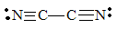
each carbon has a orbital geometry = linear
molecular geometry = linear
bond angle = 180°
hybridization = sp
- Hydrazine (N₂H₄) is used as a rocket fuel. The combustion products are nitrogen (N₂) and water (H₂O) (12 points).
  - Write the balanced chemical equation and then draw the Lewis structures of the reactants and products.
N₂H_{4 (l)} + O_{2 (g)} → N_{2 (g)} + 2 H₂O _{(g)}

  - Use the above information about bond energies to estimate the change in enthalpy associated with the combustion of 1 mol of hydrazine.
$$∆H_{rxn}=\sum{{∆H}_{broken}}-\sum{{∆H}_{formed}}$$
$$∆H_{rxn}=[\left({∆H}_{O=O})+2*2∆H_{N-H}+∆H_{N-N}\right]-[∆H_{N≡N}+2*2∆H_{O-H}]$$
$$∆H_{rxn}=\left[495\frac{kJ}{mol}+2*2\left(388\frac{kJ}{mol}\right)+163\frac{kJ}{mol}\right]-\left[941\frac{kJ}{mol}+2*2\left(463\frac{kJ}{mol}\right)\right]$$
$$∆H_{rxn}=\left[495\frac{kJ}{mol}+2\left(388\frac{kJ}{mol}\right)+418\frac{kJ}{mol}\right]=-583\frac{kJ}{mol}$$
- Describe the valence bond picture of bonding in ethylene, C₂H₂, which is shown below. Identify the number of valence electrons, the number of pi bonds, the number of sigma bonds, and the hybridization of the carbon atomic orbitals (4 points).
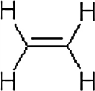
Ethylene has 12 valence electrons, 1 pi bond, 5 sigma bonds, and the carbon hybridization is sp².

- Use the 1s orbital of hydrogen to form atomic orbitals for H₂ and draw the molecular orbital energy-level diagram. Label the energy levels with the MO symbols. Which of the following species of hydrogen would you predict to be stable based on your energy-level diagram? Explain (6 points).
H₂²⁺, H₂⁺, H₂, H₂–, H₂^{2–}
σ*________

σ________
Bond orders are 0 for H₂²⁺; 0.5 for H₂⁺; 1 for H₂; 0.5 for H₂–; 0 for H₂^{2–}. Expect those species with bond orders greater than 0 to be stable.

- Would water rise to the same height in a capillary tube made of polyethylene plastic as it does in a glass capillary tube of the same diameter? Polyethylene is a hydrocarbon, and glass is mostly silicon dioxide. Explain (3 points).
Water will not interact as strongly with the hydrocarbon walls of a plastic capillary tube as it does with the silicon dioxide walls of a glass capillary tube where oxygen is available for hydrogen bonding with water. Consequently, water will rise higher in the glass capillary tube.

- CH₂F₂ has a dipole moment of 1.93 D and a boiling point of –52°C. CH₂Cl₂ has a dipole moment of 1.60 D and a boiling point of 40°C. Why is the boiling point of dichloromethane so much higher than that of difluoromethane (4 points)?

Both molecules have dipole–dipole and dispersion interactions. Difluoromethane has the larger dipole–dipole interactions because it has the larger dipole moment, but dichloromethane has the larger dispersion interactions because it has more electrons. Evidently, the larger dispersion interactions are more important in producing a higher boiling point for dichloromethane.

Temperature (K) | Pressure (torr)
65 | 130.5
70 | 289.5
75 | 570.8
80 | 1028
85 | 1718
- The vapor pressure of nitrogen at several different temperatures is shown: (15 points)
  - Make a linear graph.

Temperature (K) | Pressure (torr) | 1/T (1/K) | Ln(P)
65 | 130.5 | 0.015 | 4.8714
70 | 289.5 | 0.014 | 5.6682
75 | 570.8 | 0.013 | 6.3470
80 | 1028 | 0.013 | 6.9354
85 | 1718 | 0.012 | 7.4489

The graph of pressure vs. temperature is exponential. But, the graph of ln(P) vs. 1/T is linear:

  - Using points off your graph determine the equation of the best fit straight line.
$$m=\frac{7.4489-4.8714}{0.012\frac{1}{K}- 0.015\frac{1}{K}}=\frac{2.5775}{-0.003}=-859.16667 K≈-900 K$$
$$b=y-mx= 6.3470-\left(-859.16667 K\right)\left(0.013\frac{1}{K}\right)=17.5$$
$$\ln\left(P\right)=\frac{\left(-900 K\right)}{T}+17.5$$
  - Determine the heat of vaporization of nitrogen.
$$\ln\left(P\right)=-\frac{ΔH_{vap}}{R}\left(\frac{1}{T}\right)+C$$
$$m=-\frac{ΔH_{vap}}{R}⇒ΔH_{vap}=-mR=-\left(-900 K\right)\left(8.314 \frac{J}{mol K}\right)×\frac{1 kJ}{1000 J}=-7\frac{kJ}{mol} or-5.92\frac{kJ}{mol} using excel data$$
  - Determine the normal boiling point of nitrogen.
$$\frac{1}{T}=\frac{\ln\left(P\right)-C}{m}=\frac{\ln\left(760\right)-17.5}{-900 K}=0.012⇒T=83 K or 77.4 K using excel data$$

