Exam 4

Part 1: Multiple Choice (2 points each)

Directions: Please circle the best answer for each of the following questions.

- An element has a crystal structure in which the width of the cubic unit cell equals the diameter of an atom. What type of unit cell does it have?
  - Simple cubic
  - Body-centered cubic
  - Cubic closest packing
  - Hexagonal closest packing
  - Square planar
- How is the miscibility of two liquids related to their polarity?
- Nonpolar liquids are miscible with other nonpolar liquids.
- Polar liquids are not miscible with nonpolar liquids.
- Polar liquids are not miscible with other polar liquids
- a and b
- all of the above

- What happens to the vapor pressure of a substance when its surface area is increased at constant temperature?
- The vapor pressure increases.
- The vapor pressure decreases.
- The vapor pressure remains the same.
- Not enough information
- none of the above

- Which one of the following solutions has the highest vapor pressure?
  - 20.0 g of glucose (C₆H₁₂O₆) in 100.0 mL of water
  - 20.0 g of sucrose (C₁₂H₂₂O₁₁) in 100.0 mL of water
  - 10.0 g of potassium acetate (KC₂H₃O₂) in 100.0 mL of water
  - all of the above
  - none of the above

- Red blood cells are placed into pure water. Which of the following statements is true?
  - The osmotic pressure inside the cells equals the osmotic pressure outside.
  - Water molecules flow out of the red blood cells, causing them to collapse.
  - The osmotic pressure of the cell contents increases, causing the cells to burst.
  - Water flows into the red blood cells, causing them to swell and burst.
  - a and b

- A crude type of disappearing ink is based on the following endothermic equilibrium:
[Co(H₂O)₆]Cl_{2 (aq)} $⇌$ [CoCl₂(H₂O)₄] _{(aq)} + 2 H₂O _{(g)}
Colorless Blue
If the reactant solution is used to write on a piece of paper and the paper is allowed to partially dry, what can be done to bring out the colored handwriting?
  - add water
  - put the paper in the oven
  - put the paper in the freezer
  - decrease the volume
  - none of the above

- In a reaction mixture containing only products, what is the value of Q?
  - -1
  - 1
  - 0
  - ∞
  - It cannot be determined without concentrations.

- What is ∆n for the following equation in relating K_{c} to K_{p}? N_{2 (g)} + 3 Cl_{2 (g)} $⇌$ 2 NCl_{3 (g)}
  - 4
  - -4
  - -2
  - 2
  - 1

- Give the major forces in seawater.
  - Dipole-dipole
  - Dispersion
  - Hydrogen bonding
  - Ion-ion
  - Ion-dipole

- Give the reason that antifreeze is added to a car radiator.
  - The freezing point is lowered and the boiling point is elevated.
  - The freezing point is elevated and the boiling point is lowered.
  - The freezing point and boiling point are elevated.
  - The freezing point and boiling point are lowered.
  - none of the above

Part 2: Short Answer

Directions: Answer each of the following questions. Be sure to use complete sentences where appropriate. For full credit be sure to show all of your work.
- Consider the phase diagram shown below. Evaluate if the following statements are true or false. If they are false, correct them (7 points).
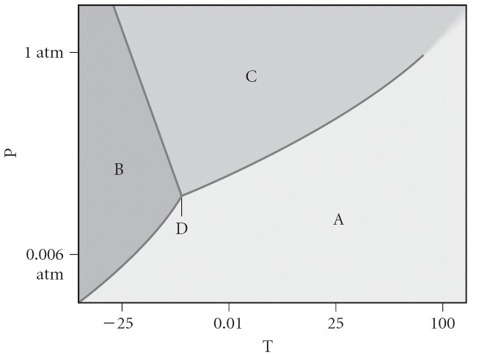
A = solid, B = gas, C = liquid
The triple point occurs at a temperature of -10 °C.
The solid phase of this substance is lower in density than the liquid phase.
The line separating the solid and liquid phases represents the ∆H_{vap}.

- A 10.0 g sample of p-dichlorobenzene, a component of mothballs, is dissolved in 80.0 g of benzene, C₆H₆. The freezing point of the solution is 1.20 °C. The freezing point of pure benzene is 5.48 °C. What is the approximate molar mass of p-dichlorobenzene? K_{f} for benzene is 5.12 °C/m (7 points).

- 3.179 M solution of glucose (C₆H₁₂O₆) has a density of 1.381 g/mL at 25ºC (20 points). Calculate
  - the mass percent of glucose

  - the mole fraction of glucose

  - The molality of glucose

  - The vapor pressure of water at 25ºC is 23.8 torr. What is the vapor pressure of the glucose solution under these same conditions?

  - What is the boiling point of the glucose solution (K_{b} water is 0.512 °C/m)?

  - What is the osmotic pressure of the glucose solution at 20ºC?

- Consider the following reactions containing hydrogen and deuterium atoms. A deuterium is a hydrogen-2 atom. The equilibrium constant is given for one of the reactions below. Determine the value of the missing equilibrium constant (6 points).
2 HD _{(g)} $⇌$ H_{2 (g)} + D_{2 (g)} K_{c} = 0.28
6 H_{2 (g)} + 6 D_{2 (g)} $⇌$ 12 HD _{(g)} K_{c}’ = ?

- In The Rhime of the Ancient Mariner the poet Samuel Taylor Coleridge wrote, “…Water, water, everywhere/And all the boards did shrink…” Explain this effect in terms of osmosis (4 points).

- A drooping plant can be made upright by watering the ground around it. Explain (3 points).

- Rhodium crystallized in a face-centered cubic unit cell. The radius of a rhodium atom is 135 pm. Determine the density of rhodium in g/cm³ (6 points).

- The boiling point of phosphine, PH₃, (-88 °C) is lower than that of ammonia (-33 °C) even though phosphine has twice the molar mass of ammonia. Why (3 points)?

- The vapor pressure of a substance is measured over a range of temperatures. A plot of the natural log of the vapor pressure versus the inverse of the temperature (in Kelvin) produces a straight line with a slope of -3.34 x 10³ K. Find the enthalpy of vaporization of the substance in kJ/mol (5 points).

- Suppose that 0.83 g of water condenses on a 85.0 g block of iron that is initially at 24 °C. If the heat released during condensation goes only to warming the iron block, what is the final temperature in degrees Celsius of the iron block? (Assume a constant enthalpy of vaporization for water of 44.0 kJ/mol and the specific heat of iron is 0.449 J/g °C.) (8 points)

- Consider the following reaction: NH₄HS _{(s)} $⇌$ NH_{3 (g)} + H₂S _{(g)}
At a certain temperature, K_{c} = 8.5 x 10⁻³M². A reaction mixture at this temperature containing solid NH₄HS and [NH₃] = 0.166 M and [H₂S] = 0.166 M. will more of the solid form or will some of the existing solid decompose as equilibrium is reached (4 points)?

- Consider the following reaction: Fe³⁺ _{(aq)} + SCN⁻ _{(aq)} ₎ $⇌$ FeSCN²⁺ _{(aq)}
A solution is made containing an initial [Fe³⁺] of 1.2 x 10⁻³ M and an initial [SCN⁻] of 8.2 x 10⁻⁴ M. At equilibrium [FeSCN²⁺] is 1.7 x 10⁻⁴ M. Calculate the value of the equilibrium constant K_{c} (10 points).

