Exam 3

Part 1: Multiple Choice (2 points each)

Directions: Please circle the best answer for each of the following questions.

- Safety goggles must be worn when
- you are using chemicals.
- anyone is using flames.
- anyone is using chemicals.
- if my teacher is wearing them.
- all of the above

- A ligand is any _______ forming a coordinate bond to a metal cation.
  - Lewis acid
  - ion
  - Lewis base
  - organic compound
  - species

- Which ligand below is not correctly named?
  - H₂O, hydro
  - NH₃, ammine
  - CN⁻, cyano
  - CO, carbonyl
  - OH⁻, hydroxo

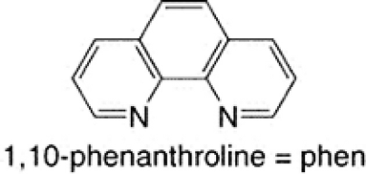
- 1,10-phenanthroline, which is shown below, is an example of a ________ ligand.
  - monodentate
  - bidentate
  - tridentate
  - good
  - poor
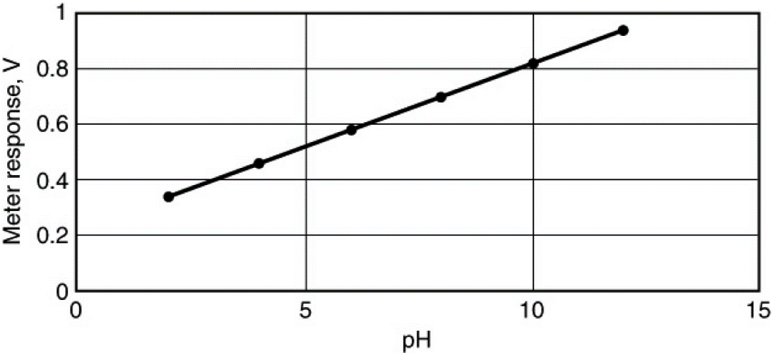
- A pH meter uses an electrode arrangement that provides a voltage that depends on [H⁺], in accord with the Nernst equation. The following plot illustrates this dependence. What effect would changing temperature have on the measurement and this plot?
  - A change of temperature would have no effect.
  - An increase in temperature would increase the slope.
  - An increase in temperature would decrease the slope.
  - An increase in temperature would increase the y intercept.
  - An increase in temperature would decrease the y intercept.
- For an octahedral complex what metal d orbitals are directly towards the ligand?
  - d_{xy}, d_{xz}
  - d_{xy}, d_{xz}, d_{yz}
  - $d_{z^{2}}, d_{x^{2}-y^{2}}$
  - $d_{z^{2}}, d_{xz}, d_{yz}$
  - none of the above

- The unit of current, ampere (A), is defined as ________
  - 1 C.
  - 1 C/s.
  - 1 mol of electrons.
  - 10 C/s.
  - 96,500 C/s.

- The standard cell potential for the nickel–cadmium battery is 1.35 V, and the cell reaction can be written as
2 NiO(OH) (s) + 2 H₂O (l) + Cd (s) → 2 Ni(OH)₂ (s) + Cd(OH)₂ (s)
Which one of the following statements do you expect to be true based on the Nernst equation? Note Q = reaction quotient, and K = equilibrium constant for the cell reaction.
  - As the battery is used, the cell voltage approaches zero because Q approaches K, in value.
  - When the battery no longer works, the cell voltage is zero because Q = K.
  - As the battery is used, the cell voltage does not change because Q equals 1.
  - When the battery is fully charged, Q > K.
  - When the battery is fully charged, Q < K.
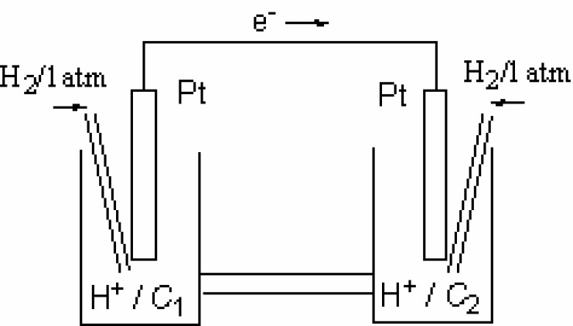
- Which statement about this concentration cell is incorrect?
  - The electrode on the left side is the anode.
  - The electrode on the left side is the electron.
  - Anions in the salt bridge migrate to the left side.
  - Hydrogen ions are reduced on the right side.
  - The pH of the solution on the right side is higher than the pH on the left side.

- Which statement about corrosion is not correct?
  - Corrosion is promoted by the presence of water.
  - Corrosion is promoted by the presence of electrolytes.
  - Corrosion is promoted by contact between dissimilar metals.
  - Surface oxidation protects metals such as iron, stainless steel, and aluminum from corrosion.
  - Cathodic protection prevents corrosion of an object by attaching it to a metal that serves as the cathode of the resulting electrochemical cell.

Part 2: Short Answer

Directions: Answer each of the following questions. Be sure to use complete sentences where appropriate. For full credit be sure to show all of your work.
- What determines whether a transition metal ion is in a high-spin or a low-spin electron configuration (3 points)?
The magnitude of the crystal field splitting (A) compared to the electron-pairing energy in a d orbital (B). If A is larger than B, low spin results. If B is larger than A, then high spin results.

- Briefly account for each of the following observations (4 points):
  - Atomic radii decreases in the order Sc > Ti > V
The decrease in radii with increasing atomic number is expected because the added d electrons only partially shield the added nuclear charge. As a result, Z_{eff} increases. With increasing Z_{eff}, the electrons are more strongly attracted to the nucleus, and atomic size decreases.
  - Densities increase in the order Ti < V < Cr
The densities of the transition metals are inversely related to their atomic radii.

- Although Cl⁻ is a weak-field ligand and CN⁻ is a strong-field ligand, [CrCl₆]³⁻ and [Cr(CN)_{6 ]}³⁻ exhibit approximately the same amount of paramagnetism (7 points).
  - Explain.
Cr³⁺ is a 3d³ ion. Regardless of the crystal field splitting energy, the three electrons singly occupy the three lower energy d orbitals.
  - Name each complex.
[CrCl₆]³⁻ hexachlorochromate(III) ion
[Cr(CN)_{6 ]}³⁻ hexacyanochromate(III) ion
  - What is the geometry around each ion? ______________octahedral__________

- The Ni²⁺ _{(aq)} cation is green, but Zn²⁺ _{(aq)} is colorless. Explain (4 points).
Ni²⁺ _{(aq)} is green because the Ni²⁺ ion can absorb light, which promotes electrons from the filled d orbitals to the higher energy half-filled d orbitals. Zn²⁺ _{(aq)} is colorless because the d orbitals are completely filled and no electrons can be promoted, so no light is absorbed.

- Draw all possible diastereoisomers of [Cr(C₂O₄)₂(H₂O)₂]⁻. Which can exist as a pair of enantiomers (6 points)?
- In water, the titanium(III) ion, in hexaaquatitanium(III), has a broad absorption band at 500 nm (10 points).
  - What color light is absorbed by the ion? ___blue-green______
  - What color light is transmitted by the ion? __red-violet______
  - What the formula of the ion? ___[Ti(H₂O)₆]³⁺______
  - Calculate the crystal field splitting energy, Δ, in kJ/mol.
$$∆=\frac{hc}{λ}=\frac{\left(6.626×{10}^{-34} Js\right)(3.00×{10}^{8}\frac{m}{s})}{500×{10}^{-9} m}=3.9756×{10}^{-19}\frac{J}{ion}$$
$$3.9756×{10}^{-19}\frac{J}{ion}×\frac{6.022×{10}^{23} ions}{1 mol}×\frac{1 kJ}{1000 J}=239\frac{kJ}{mol}$$

- Would you expect the following compounds to have cis-trans isomers, mer-fac isomers, or no geometric isomers (5 points)?
  - [CuCl₂Br₂]²⁻ cis-trans isomers
  - [Fe(NH₃)₅Cl]²⁺ no geometric isomers
  - [Ti(H₂O)₄(OH)₂]²⁺ cis-trans isomers
  - [Co(NH₃)₃Cl₃] mer-fac isomers

- The anode in an electrochemical cell is defined as the electrode where oxidation takes place. Why is the anode in an electrolytic cell connected to the positive (+) terminal of an external supply, whereas the anode in a voltaic cell battery is connected to the negative (-) terminal (5 points).
The signs of the electrodes in a cell indicate the direction of electron flow. In a voltaic cell, the electrons are produced at the anode so a negative (-) charge builds up there; in an electrolytic cell, electrons are being forced onto the cathode so that it builds up a negative (-) charge with the anode having a positive (+) charge. The flow of electrons in the outside circuit is reversed in an electrolytic cell compared to the flow in a voltaic cell.
- The following cell reactions occur spontaneously (8 points):
B + A⁺ → B⁺ + A
C + A⁺ → C⁺ + A
B + C⁺ → B⁺ + C
- Arrange the following reaction half-reactions in order of decreasing tendency to occur: A⁺ + e⁻ → A, B⁺ + e⁻ → B, C⁺ + e⁻ → C.
Looking at the equations above B > A, C > A, B > C, therefore, B > C > A, so
A⁺ + e⁻ → A
C⁺ + e⁻ → C
B⁺ + e⁻ → B
- Which of these substances (A, A⁺, B, B⁺, C, C⁺) is the strongest oxidizing agent? __A⁺
- Which is the strongest reducing agent? __B
- Which of the three cell reactions delivers the highest voltage? ____ B + A⁺ → B⁺ + A
- A current of 15.0 A electroplated 50.0 g of hafnium metal from an aqueous solution in 2.00 hours. What was the oxidation number of hafnium in the solution (8 points)?
$$15.0 A×\frac{1 C}{1 A s}×\frac{3600 S}{1 hr}×\frac{2.00 hr}{1}×\frac{1 mol e^{-}}{96500 C}×\frac{178.5 g Hf}{1 mol Hf}×\frac{1}{50.0 g Hf}=\frac{4 mol e^{-}}{1 mol Hf}$$
Hf⁴⁺

- An electrochemical cell is based on the following two half-reactions:
Use the following reduction potentials in the problems below:
MnO₄⁻ _{(aq)} + 4 H⁺ _{(aq)} + 3 e⁻ → MnO_{2 (s)} + 2 H₂O _{(l)} E° = 1.68 V
Pb²⁺ _{(aq)} + 2 e⁻ → Pb _{(s)} E° = -0.13 V
Red: MnO₄⁻ _{(aq)} (1.50 M) + 4 H⁺ _{(aq)} (2.0 M) + 3 e⁻ → MnO_{2 (s)} + 2 H₂O _{(l)}
Ox: Pb _{(s)} → Pb²⁺ _{(aq)} (0.10 M) + 2 e⁻
Calculate the cell potential at 25 °C (8 points).
Red: (MnO₄⁻ _{(aq)} + 4 H⁺ _{(aq)} + 3 e⁻ → MnO_{2 (s)} + 2 H₂O _{(l)}) × 2 E° = 1.68 V
Ox: + (Pb _{(s)} → Pb²⁺ _{(aq)} + 2 e⁻ ) × 3 E° = 0.13 V
2 MnO₄⁻ _{(aq)} + 8 H⁺ _{(aq)} + 6 e⁻ + 3 Pb _{(s)} → 2 MnO_{2 (s)} + 4 H₂O _{(l)} + 3 Pb²⁺ _{(aq)} + 6 e⁻
2 MnO₄⁻ _{(aq)} + 8 H⁺ _{(aq)} + 3 Pb _{(s)} → 2 MnO_{2 (s)} + 4 H₂O _{(l)} + 3 Pb²⁺ _{(aq)} E° = 1.81 V
$$E_{cell}=E_{cell}^{°}+\frac{RT}{nF} lnQ$$
$$E_{cell}=E_{cell}^{°}+\frac{RT}{nF} ln\left(\frac{{\left[{Pb}^{2+}\right]}^{3}}{{\left[{MnO}_{4}^{-}\right]}^{2}{\left[H^{+}\right]}^{8}}\right)$$
$$E_{cell}=1.81 V+\frac{\left(8.314\frac{J}{mol K}\right)(298 K)}{\left(6 mol e^{-}\right)\left(96485\frac{C}{mol e^{-}}\right)}×\frac{1 C V}{1 J} ln\left(\frac{{\left[0.10\right]}^{3}}{{\left[1.50\right]}^{2}{\left[2.0\right]}^{8}}\right)$$
$$E_{cell}=1.81 V+\frac{\left(8.314\frac{J}{mol K}\right)(298 K)}{\left(6 mol e^{-}\right)\left(96485\frac{C}{mol e^{-}}\right)}×\frac{1 C V}{1 J} ln\left(1.736×{10}^{-6}\right)$$
$$E_{cell}=1.81 V+0.057 V≈1.87 V$$
- The following half-reactions that when combined result in a spontaneous reaction conditions (12 points):
NO₃⁻ _{(aq)} + 4 H⁺ _{(aq)} + 3 e⁻ NO _{(g)} + 2 H₂O _{(l)} E° = +0.96 V
Hg₂²⁺ _{(aq)} + 2 e⁻ 2 Hg _{(l)} E° = +0.79 V
- Determine the net ionic equation and the standard cell potential.
Oxidation: (2 Hg _{(l)} Hg₂²⁺ _{(aq)} + 2 e⁻) x 3 E° = -0.79 V
Reduction: (NO₃⁻ _{(aq)} + 4 H⁺ _{(aq)} + 3 e⁻ NO _{(g)} + 2 H₂O _{(l)} ) x 2 E° = +0.96 V
2 NO₃⁻ _{(aq)} + 8 H⁺ _{(aq)} + 6 Hg _{(l)} 3 Hg₂²⁺ _{(aq)} + 2 NO _{(g)} + 4 H₂O _{(l)} E° = 0.17 V

- Write the cell notation for the reaction.
Pt _{(s)} | Hg _{(l)} | Hg₂²⁺ _{(aq)} || NO₃⁻ _{(aq)}, H⁺ _{(aq)} | NO _{(g)} | Pt _{(s)}

- Calculate the ΔG°.
$$∆G^{°}=-nFE^{°}=-\left(6 mol e^{-}\right)\left(96485\frac{C}{mol e^{-}}\right)\left(0.17 V\right)\left(\frac{1 J}{1 C V}\right)\left(\frac{1 kJ}{1000 J}\right)=-98 kJ$$

