Exam 4

Part 1: Multiple Choice (2 points each)

Directions: Please circle the best answer for each of the following questions.

- The isotope “belt of stability” is an area in a plot of ________
- nuclear binding energy versus atomic number.
- isotopic strength versus isotopic weakness.
- nuclear mass versus mass number.
- neutron number versus atomic number.
- mass number versus atomic number.

- A half-life is ________
- the life that a nuclear chemist leads.
- half of the lifetime of an unstable nucleus.
- the time for one-half of the unstable nuclei to decay.
- constantly changing.
- independent of the rate constant for decay.

- Cardiac pacemakers once used plutonium-238 as a power source. Plutonium-238 decays by the emission of gamma rays and alpha particles. This emission is not particularly harmful because ________
- gamma rays are not absorbed very strongly by biological tissue, and alpha particles do not penetrate beyond the container.
- gamma rays and alpha particles are the least dangerous form of radiation.
- gamma rays and alpha particles do not penetrate beyond the container.
- gamma rays are absorbed by the container, and alpha particles do not affect biological tissue.
- tissue damage caused by gamma rays and alpha particles is rapidly repaired by enzymes.

- The purpose of control rods in a fission reactor is to ________
- cool down the reactor fuel.
- absorb neutrons generated in the fission process.
- prevent oxygen from reaching the fuel.
- absorb the electrons emitted in the fission process.
- enhance the neutron capture process.

- What material is often used for radiation shielding?
- Tin
- Gold
- Lead
- Plutonium
- Helium

- Which statement best describes how these three molecules are related? 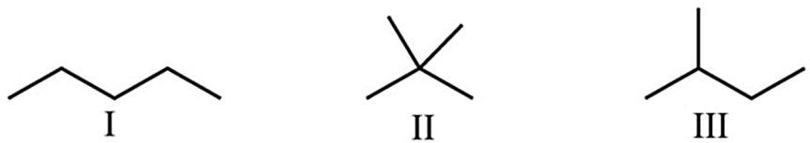
- They are not related, they are different molecules.
- They are structural isomers.
- They are stereoisomers.
- They illustrate cis-trans isomerization.
- They are the same compound.
- Which of the following is an amine functional group?
- –COOH
- –OH
- –SH
- –NH₂
- –CONH₂

- An alkyne is characterized by a ________ bond between carbon atoms that have a ________ local molecular geometry and ________ hybridization.
- single; linear; sp
- single; linear; sp³
- double; trigonal planar; sp²
- double; tetrahedral; sp³
- triple; linear; sp

- Which one of the following behaves like an acid?
- CH₃COCH₃
- (CH₃)₂NH
- C₂H₅OH
- C₂H₅COOH
- a and c

- Which form of protection is commonly used and/or available in chemistry laboratories to protect skin?
- disposable and nondisposable gloves
- clothes
- laboratory aprons and coats
- safety glasses or goggles
- all of the above

Part 2: Short Answer

Directions: Answer each of the following questions. Be sure to use complete sentences where appropriate. For full credit be sure to show all of your work.
- How do chemical and nuclear reactions differ in (4 points)
  - effect on rate of higher reactant concentration?

  - effect on yield of higher reactant concentration?

- Why is ionizing radiation more harmful to children than adults (4 points)?

- A person’s body generates about 0.20 µCi of radioactivity! Determine the total radioactivity emitted by 18 students in a lecture hall. (1 Ci = 3.7 × 10¹⁰ Bq and 1 Bq = 1 decay/s) (6 points)

- Define chain reaction in terms of the fission of uranium nucleus (3 points).

- When uranium-235 nuclei are bombarded with neutrons (1.0087 amu), they can split apart in a variety of ways, like glass balls that shatter into pieces of different sizes. In one process, uranium-235 (235.04 amu) forms barium-142 (91.92 amu) and krpton-92 (141.92 amu) (12 points).
  - Write the balanced nuclear fission equation

  - Calculate the energy (in joules) released when 1.0 g of uranium-235 undergoes this fission reaction (1 amu = 1.6605 x 10⁻²⁷ kg).

- The activity of an iodine-131 source (beta emitter, t_{1/2} = 8.05 days), which is used to monitor the functioning of the thyroid gland, is 500 Bq (12 points).
  - Write the balanced decay reaction.

  - How long will it be before the activity is 10 disintegrations per second (1 Becquerel = 1 disintegrations per second).

- Identify all of the functional groups in the following molecule (3 points).
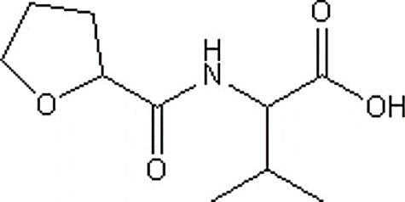

- Answer the following questions about the reaction of 2-pentene and hydrogen gas (10 points).
- Write the balanced chemical reaction.

- What is the minimum amount of hydrogen gas, in grams, required to completely hydrogenate 13.6 kg of 2-pentene?

- Write the condensation reaction for the esterification of propanoic acid and methanol. Name the products (5 points):

- Arrange the following hydrocarbons in order of decreasing melting point (5 points): trans-2-butene, cis-2-butene, butane, ethane, and 2-butyne

- Name the following compounds (4 points):

- Benzaldehyde is responsible for the odor of almonds and cherries (12 points).
- Draw the structure of benzaldehyde.

- It has a normal boiling point of 179.0 °C. Calculate the boiling point of benzaldehyde at the summit of Pikes Peak, Colorado, if the atmospheric pressure is 447 torr. ΔH_{vap} for benzaldehyde is 4.88 kJ/mol.

