Exam 3

Part 1: Multiple Choice (2 points each)

Directions: Please circle the best answer for each of the following questions.

- Identify the process that is spontaneous.
  - Rusting of iron
  - Electrolysis
  - Browning of bread
  - Photosynthesis
  - Frying an egg

- Which one of the following has the highest standard molar entropy, S°, at 25 °C?
  - NaF _{(s)}
  - NaCl _{(s)}
  - NaBr _{(s)}
  - NaI _{(s)}
  - They all have the same value.

- Given the following equation: 3 NO _{(g)} → N₂O _{(g)} + NO_{2 (g)} ∆G°_{rxn} = + 23.0 kJ
Calculate ∆G°_{rxn} for: N₂O _{(g)} + NO_{2 (g)} → 3 NO _{(g)}
  - -7.67 kJ
  - 23.0 kJ
  - -23.0 kJ
  - 69.0 kJ
  - -69.0 kJ

- Which of the following processes has a ∆S > 0?
  - SO_{2 (l)} → SO_{2 (s)}
  - N_{2 (g)} + 3 H_{2 (g)} → 2 NH_{3 (g)}
  - CH_{4 (g)} + H₂O _{(g)} → CO _{(g)} + 3 H_{2 (g)}
  - K₂CO_{3 (s)} + H₂O _{(g)} + CO_{2 (g)} → 2 KHCO_{3 (s)}
  - All of the above

- Balance the following redox reaction if it occurs in basic solution. What are the coefficients in front of Br₂ and OH⁻ in the balanced reaction?
  - Br₂ = 1, OH⁻ = 2
  - Br₂ = 2, OH⁻ = 5
  - Br₂ = 3, OH⁻ = 3
  - Br₂ = 1, OH⁻ = 6
  - Br₂ = 3, OH⁻ = 6

- Identify the location of oxidation in an electrochemical cell.
  - The anode
  - The cathode
  - The electrode
  - The salt bridge
  - The socket

- Determine the cell notation for the redox reaction given below:
3 Cl_{2 (g)} + 2 Fe _{(s)} → 6 Cl⁻ _{(aq)} + 2 Fe³⁺ _{(aq)}
- Cl_{2 (g)} | Cl⁻ _{(aq)} | Pt _{(s)} || Fe _{(s)} | Fe³⁺ _{(aq)}
- Cl⁻ _{(aq)} | Cl_{2 (g)} | Pt _{(s)} || Fe³⁺ _{(aq)} | Fe _{(s)}
- Fe³⁺ _{(aq)} | Fe _{(s)} || Cl⁻ _{(aq)} | Cl_{2 (g)} | Pt _{(s)}
- Fe _{(s)} | Cl_{2 (g)} || Fe³⁺ _{(aq)} | Cl⁻ _{(aq)} | Pt _{(s)}
- Fe _{(s)} | Fe³⁺ _{(aq)} || Cl_{2 (g)} | Cl⁻ _{(aq)} | Pt _{(s)}

- How many electrons are transferred in the following reaction? (The reaction is unbalanced.)
Ni _{(s)} + Cr³⁺ _{(aq)} → Cr _{(s)} + Ni²⁺ _{(aq)}
  - 6
  - 4
  - 3
  - 2
  - 1
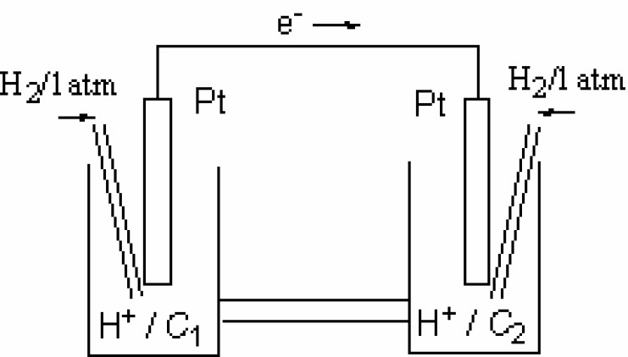
- Which statement about this concentration cell is correct?
  - The electrode on the left side is the anode.
  - The electrode on the right side is the electron.
  - Anions in the salt bridge migrate to the right side.
  - Hydrogen ions are reduced on the left side.
  - The pH of the solution on the right side is lower than the pH on the left side.

- It is okay to take off eye protection in chemistry laboratories
- once you are done using chemicals, even if those around you are still using chemicals.
- when you are writing notes in a lab notebook and not actively using chemicals.
- when working at the chemical hood with the safety shield down.
- if, at the end of the lab, you need to store your goggles in a drawer or locker in the lab and quickly exit the lab.
- all of the above

Part 2: Short Answer

Directions: Answer each of the following questions. Be sure to use complete sentences where appropriate. For full credit be sure to show all of your work.
- A voltaic cell is set up at 25 °C with the half-cells Al³⁺ (0.0010 M) |Al and Ni²⁺ (0.50 M) |Ni. Write an equation for the reaction that occurs when the cell generates an electric current and determine the cell potential (8 points). Given:
Al³⁺ _{(aq)} + 3 e⁻ → Al _{(s)} E° = -1.662 V
Ni²⁺ _{(aq)} + 2 e⁻ → Ni _{(s)} E° = -0.257 V

- The standard cell potential, E°_{cell}, for the reduction of silver ions with copper metal is +0.462 V at 25 °C. Calculate ∆_{r}G° in kJ for this reaction (6 points).

- The molar mass of a metal (M) is 50.9 g/mol and it forms a chloride of unknown composition. Electrolysis of a sample of the molten chloride with a current of 6.42 A for 23.6 minutes produces 1.20 g of M at the cathode (8 points).
  - Find the empirical formula of the chloride.

  - What is the most likely identity of M?

- Why do some electrochemical cells employ inert electrodes such as graphite (3 points)?

- Use the following data for 1 M HNO₃ and gold metal (6 points):
Au _{(s)} | Au³⁺ _{(aq)} || NO₃⁻ _{(aq)}, H⁺ _{(aq)}| NO _{(g)} | C _{(s)}
E°_{cathode} = 0.96 V
E°_{anode} = 1.50 V
  - Write the balanced net ionic equation.

  - Predict whether 1 M HNO₃ will dissolve gold metal to form 1 M Au³⁺ solution.

- The number of ways of getting a two when rolling a pair of dice is 2 and the number of ways of getting a seven is 6. What is the entropy change for going from a roll of a two to a roll of seven (5 points)?

- For a particular reaction ΔH°_{rxn} = -124 kJ, ΔS°_{rxn} = 256 J/K, and T = 292 K (8 points).
- Calculate ΔS_{universe}.

- Predict whether the reaction will be spontaneous or nonspontaneous. Show calculations to justify your answer.

Substance | ∆G° _{f} (kJ/mol)
I_{2 (s)} | 0
IO₃⁻ _{(aq)} | -128.0
I⁻ _{(aq)} | -51.57
H₂O _{(l)} | -237.1
OH⁻ _{(aq)} | -157.3
- Consider the balanced equation (12 points):
6 OH⁻ _{(aq)} + 3 I_{2 (s)} IO₃⁻ _{(aq)} + 3 H₂O _{(l)} + 5 I⁻ _{(aq)}
- Calculate ∆G° for the reaction at 25 °C.

- Is the reaction spontaneous or nonspontaneous under standard-state conditions?

- What pH is required for the reaction to be at equilibrium at 25 °C when [I⁻] = 0.10 M and [IO₃⁻] = 0.50 M?

- The temperature dependence of the equilibrium constant of the reaction:
2 CO_{2 (g)} $⇌$ 2 CO _{(g)} + O_{2 (g)}
can be expressed as ln(K_{p}) = 20.1 - 66,662/(T/K) (8 points).
- What is the standard enthalpy in kJ/mol of the forward process?

- What is the standard entropy of the forward process?

Substance | S° (J/mol K)
CH_{4 (g)} | 186.2
O_{2 (g)} | 205.0
H₂O _{(l)} | 70.0
CO_{2 (g)} | 213.6
- Answer the following questions about the reaction of 10.0 g of methane, CH₄, and 10.0 g of oxygen gas? Given (16 points):

- Write the balanced chemical equation.

- What is the standard entropy change? Hint you will need to use an ICE table.

