Math 110 Name________________________

Chapter 4 & 5 Review

Graph each inequality and write the solution set using both set-builder notation and interval notation.

1. 
2. 
3. 
4. 
5. 
6. 
7. Solve for *m*: 
8. Solve for *k*: 
9. 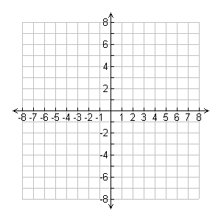 Graph the system of inequalities



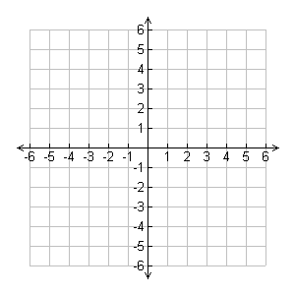

1. Graph the system of inequalities

(find all vertices/points of intersection)



1. 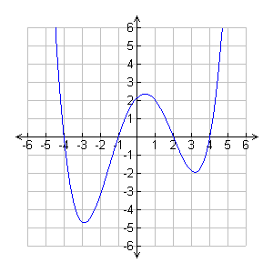 The graph to the right is that of the polynomial function . Use the graph to determine the zeros of .

Factor completely:

12. 

13. 

14. 

15. 

16. 

17. 

Solve the equations for the given variable:

18. 

19. 

20. 

21. 

22. Write a polynomial function having zeros: 2 and -3

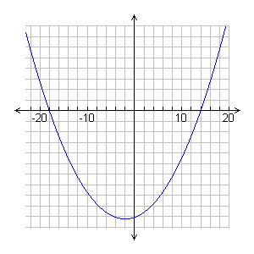23. Use the graph to factor the given polynomial: 



24. The bottom of a ladder is 6 feet from the wall. The ladder is 2 feet longer than the height that it reaches on the wall. How far up the wall does the ladder reach?

25. The width of a rectangular room is 3 feet less than the length. If the area of the room is 154 square feet, find the dimensions of the room.

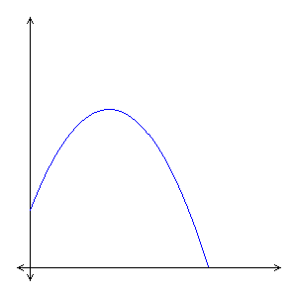26. To celebrate a town’s centennial, fireworks are launched over a lake off a dam 36 ft above the water. The height of a display, t seconds after it has been launched, is given by . After how long will the shell from the fireworks reach the water?

36ft

**Solutions:**

7

1. S.B:  Interval: 

2. S.B:  Interval: 

-4

3

3. S.B:  Interval: 

9/20

4. S.B:  Interval: 

-4/3

-14/3

-4

1

5. S.B: Interval: 

6. S.B:  Interval: 

-11

7. No Solution

8. 

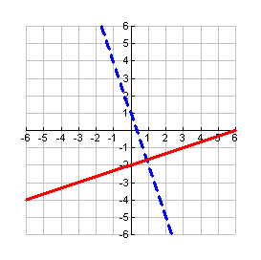9.

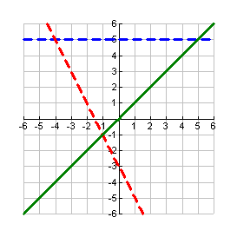10.







11. 

12. 

13. 

14. 

15. 

16. 

17. 

18. 

19. 

20. 

21. 

22. 

23.  .

24. 8 feet

25. width: 11feet   
 length: 14 feet

26. 