Name:___________________

Math 160 Lab 1 – Introduction to StatCrunch
Students in your group:

You may work with up to 3 people to complete the following lab. However, every student must turn in his or her own lab results. Write/type the names of the students you worked with in the box provided above.

You will need to copy, paste and edit your resulting graphs and tables on to this document as you complete each question. You can download this electronic document from my website, then open it and edit it with your answers and graphs.

http://www.grossmont.edu/jennyvandeneynden/Math160/M160.htm
------------------------------------------------------------------------------

StatCrunch is an online statistical package that comes with your MyStatLab account or can be purchased separately from StatCrunch.com. If you have not registered to use StatCrunch, see the “Registration Instructions” handout provided by your instructor.

You can access StatCrunch at www.StatCrunch.com

The StatCrunch software can run on any of the three major platforms: PC, MAC and UNIX. It only has the minimal requirement of a Java capable Web browser.

If you are working on your home computer and do not have a Java enabled browser, you will probably see a gray box which may or may not have a red x in it after logging in to StatCrunch.

You may also check whether your browser is Java enabled by accessing the web site http://www.javatester.org/enabled.html

Warning: If you require to access another website during your StatCrunch session, open the site in a new browser window, otherwise your StatCrunch session will close without any warning and all your data and results will be lost. This is not any StatCrunch bug, this is how all web-based applications work. Please keep this in mind.
STEP 1. LOADING DATA INTO STATCRUNCH
There are several ways to get data into StatCrunch (load the textbook data, load data directly from another web site, type it in yourself, administer a survey, etc)

Accessing your textbook data in StatCrunch:

- Go to StatCrunch.com Sign in with your StatCrunch/MyStatLab Login and Password. Once you are logged on, you will see this window (with your name instead of my name…. of course)
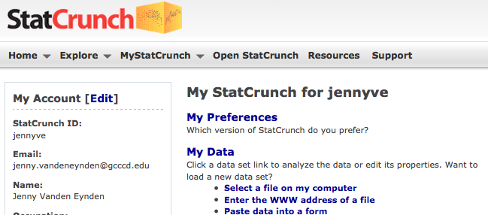

- Click on “EXPLORE” in the top menu. Then click on “GROUPS”.

- Go to the left side of your screen, under View Options, there is a “SEARCH” box. Type in and search for TRIOLA. Click on the group named “Triola Elementary Statistics 11th Edition”.
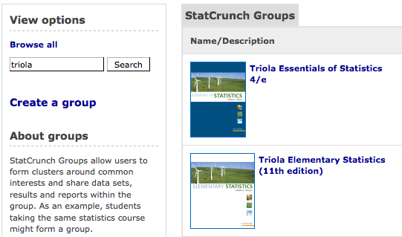
- Click on “25 data sets” to see all of the data sets (otherwise you will only see the top 5).

- Scroll down until you see HOME SALES and click on it.
You should see the HOME SALES data set in your window.
1a. What are the different variables in the data set? List them all here:

1b. For each of these variables, which are DISCRETE and which are CONTINUOUS?

1c. Scroll down to the last row of data. How many homes are in this data set?

1d. Look at the column titled “Rooms”. What is the maximum number of rooms found in this sample of homes?

CREATING BASIC TABLES AND GRAPHS

STEP 2. Construct a RELATIVE FREQUENCY TABLE from raw data.

If you have competed Step 1 then your window should look like this.

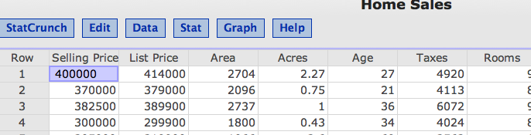

- Select STAT. This will give you a drop down menu. Choose TABLES and then FREQUENCY (you should see the following table)

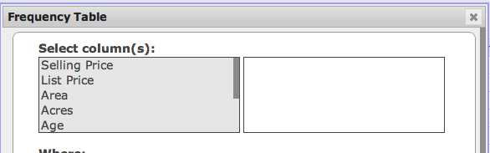

- Select “Selling price” by clicking on it. Notice that “selling price” now appears on the column to the right. Staying on this Frequency Table window, scroll down until you see TYPE and select “Relative Frequency”. Now click on “Compute!” (see bottom right button) A new window will pop up asking if you want to bin. Click OK.

- A frequency table for selling price will open up. Click on OPTIONS located in the top right corner of your current window and select “COPY” from the drop down menu. Paste that table on to this document (in the space provided below). There may be special instructions for copying and pasting. Follow instructions given.

2a. Paste your Frequency Table for “Selling Price” here.

2b. Do you have a concern with the class limits? Explain.

2c. What percentage of homes had a selling price between $250,000 to $300,000.

2d. Is the distribution of selling prices Normal, Skewed Left, or Skewed Right?

STEP 3. Construct a Histogram.

- Select GRAPH and you will get a drop down menu. Select Histogram.
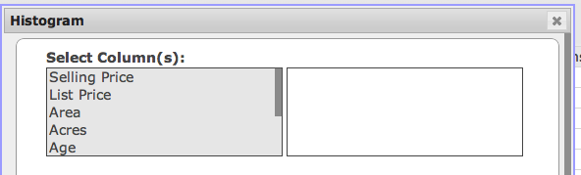

- This time select “Age” by clicking on it. Notice that “Age” now appears on the column to the right. Staying on this Histogram window, scroll down until you see “Binwidth” and type in a Binwidth of 10. Below that select/click “Display Value Above Bar”. Now click on “Compute!” (see bottom right)

- A Histogram for “Age” will open up. Click on OPTIONS located in the top right corner of your current window and select “copy” from the drop down menu. Paste that graph on to this document (in the space provided below). There may be special instructions for copying and pasting. Follow instructions given.

3a. Paste your Histogram for “Age” here.

3b. How many homes in this sample are less than 30 years old?

3c. Any outliers in this “Age” data? Explain.
STEP 4. Run Summary Statistics on Numerical Data.

- Select STAT and you will get a drop down menu. Choose SUMMARY STATS and then COLUMNS (you should see the following table)
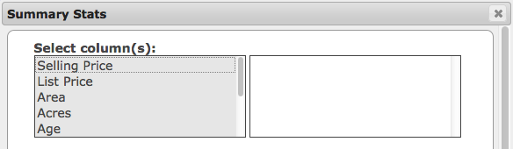

- This time select “Taxes” by scrolling down and clicking on it. Notice that “Taxes” now appears on the column to the right. Now click on “Compute!” (see bottom right) A new window will pop up asking if you want to bin. Click OK.

- A table of Summary Stats for “Taxes” will open up. Click on OPTIONS located in the top right corner of your current window and select “copy” from the drop down menu. Paste that table on to this document (in the space provided below). There may be special instructions for copying and pasting. Follow instructions given.

4a. Paste your Summary Stats for “Taxes” here.

4b. Re-type the Mean and Standard Deviation below. Round to 1 decimal place.

mean =

s =

4c. Calculate the z-score for a home whose tax bill is $5000.

z =
STEP 5. Create your own Table, Graph or Chart

- Find and open a DIFFERENT DATA SET in StatCrunch. Choose something that is interesting to you.

- Create your own Table, Graph or Chart using one variable or several variables in that data set. You have lots of choices. You can do a similar graph to those you did in the previous problems, or you can choose to create something new, like a Bar Chart, Pie Chart, Boxplot, Stem and Leaf Plot, Scatter Plot, etc. EACH GROUP MEMBER SHOULD CREATE A DIFFERENT TABLE OR GRAPH HERE.

5a. Title of Data Set:

5b. Variable(s) used in your table, graph or chart:

5c. Paste your table, graph or chart here. AGAIN, EACH GROUP MEMBER SHOULD CREATE A DIFFERENT TABLE OR GRAPH HERE.

