**Math 176: Getting Information from the Graph of a Function: Domain, Range, Extrema, Intervals of Increase/Decrease**

**Use a graphing calculator to find the Domain and Range of a function.**

**1.  Domain:**

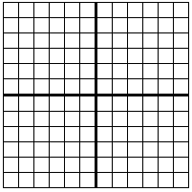

**Range:**

2. a. Find all the local maximum and minimum values of the function AND the values of *x* at which each occurs

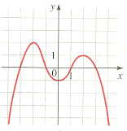

b. Find the intervals on which the function is increasing and on which the function is decreasing.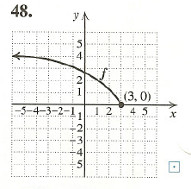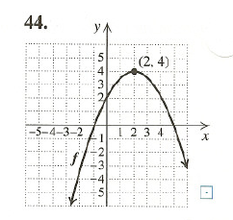

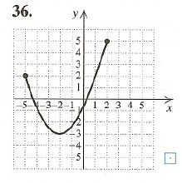

Domain: Domain: Domain:

Range: Range: Range:

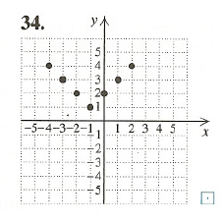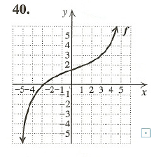

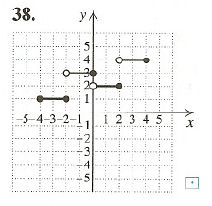

Domain: Domain: Domain:

Range: Range: Range: