- Go to www.mymathlab.com Under REGISTER click on STUDENT
Every NEW textbook sold at the Grossmont College Bookstore comes with a MyMathLab access card.

You can choose to only purchase MyMathLab without the textbook. In which case, you will be accessing the E-book from within MyMathLab.
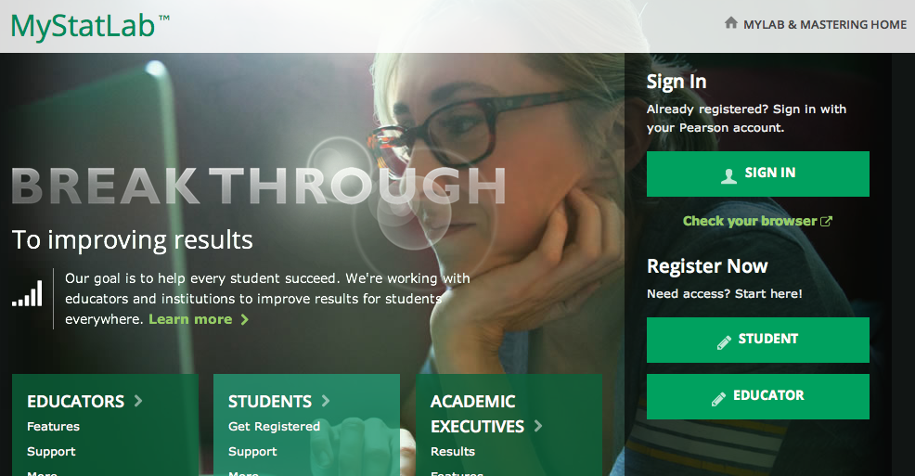

2) Type in the course ID giles50783 and click CONTINUE

3) Your course will appear to the right of your browser. THIS IS ONLY A SAMPLE your course will say Math 103 Online – Intermediate Algebra – Spring 2014 with course ID giles50783

SAMPLE

If you took this class last semester and used MyMathLab, then you already have a username and password. Sign in with your Pearson Account to access the course.

IF YOU HAVE NEVER TAKEN THIS CLASS BEFORE, then you need to create your own Pearson Account. Click on CREATE to continue.

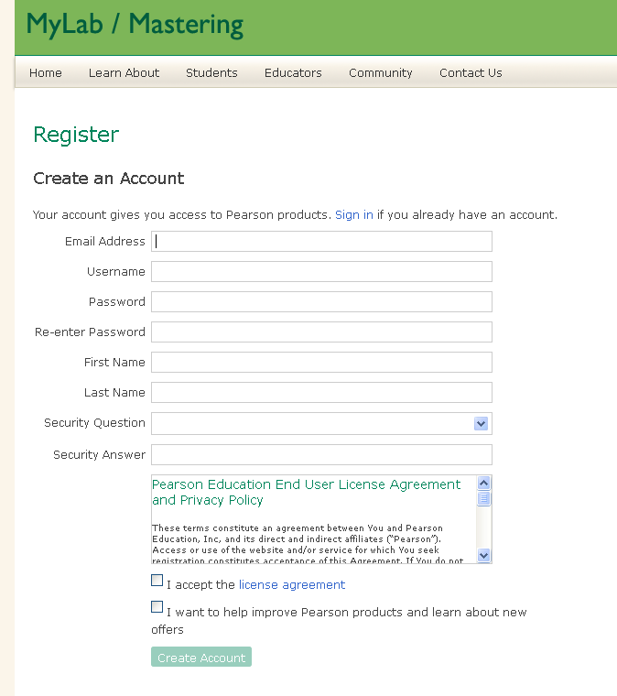
4) Once you have clicked on “CREATE”, fill out the registration form. When you create a unique username and password, make sure to WRITE it down. I will not have access to your username and password.

At the end, make sure to accept the license agreement and click on CREATE ACCOUNT.

- Next you are given three options; either you have an access code, want to pay for access using a credit card or you are waiting on financial aid and need temporary access.

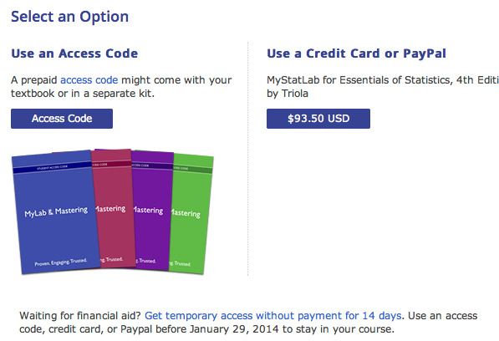
Waiting on Financial Aid?
Get temporary access NOW without payment.

- If you purchased a NEW textbook bundled with the MyMathLab ACCESS CARD then the access code is inside the card. Click “Access Code” and be prepared to enter the access code.

- If you decided not to buy a textbook and will only be purchasing access to MyMathLab then click “ $93.50 USD ” be prepared to use a credit card to make payment. Note that the price may have been increased after these instructions were typed out.

- If you are waiting for financial aid, you can access the course without payment for 14 days. Click “Get temporary access……” It is your responsibility to MAKE PAYMENT BEFORE YOUR TEMPORARY ACCESS EXPIRES. If your temporary access expires, you will receive zeros on any assignment due during the time you were without access.

- Confirmation

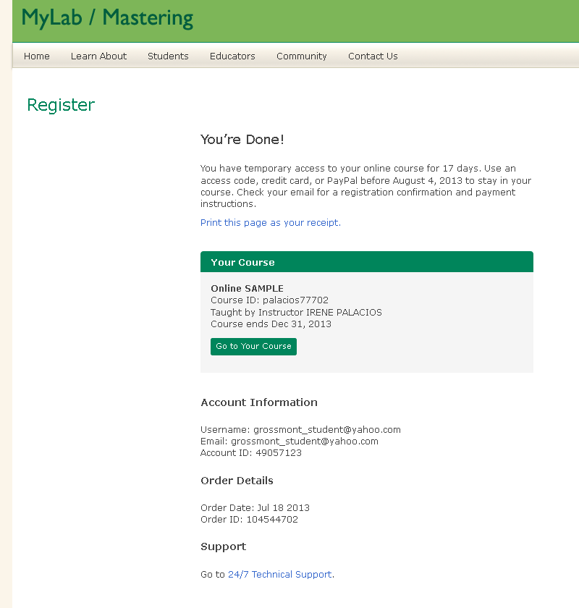
Print the confirmation and summary page for you records.

You can choose to go into the course directly…

Or you can log off and log back in by going to back to
http://www.mymathlab.com/

Click “sign in” and you SHOULD have full access.

SAMPLE

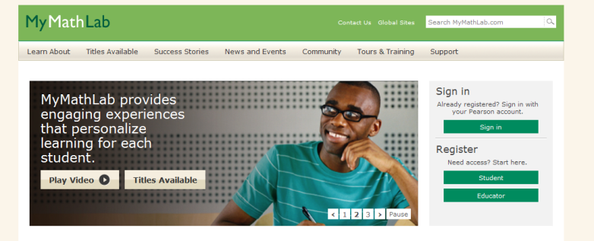

REMINDER FOR STUDENTS WHO CHOOSE TEMPORARY ACCESS:

Each time you login to your course, you will have the opportunity to change your temporary access. Make sure to do this before your temporary access expires. It’s very simple to do. Just click on “pay or use an access code now” Below is a sample only. Your window will display your Fall 2013 course with Course ID: giles50783

Temporary Access
If you're waiting for financial aid and can't pay immediately, you can access the full set of features in your instructor's online course without payment for 14 days. The temporary access option enables you to start your coursework and avoid missing deadlines set by your instructor.
You'll get reminder emails with payment instructions before your temporary access expires. To stay in your course, use an access code or pay by credit card or PayPal. If you don't pay by the expiration date, you lose access to your course and get an expiration email with payment instructions. Once you pay for full access, you regain any coursework you completed before losing access.
Note: Once you use the temporary access option for a course, you can't use the option again for that same course.

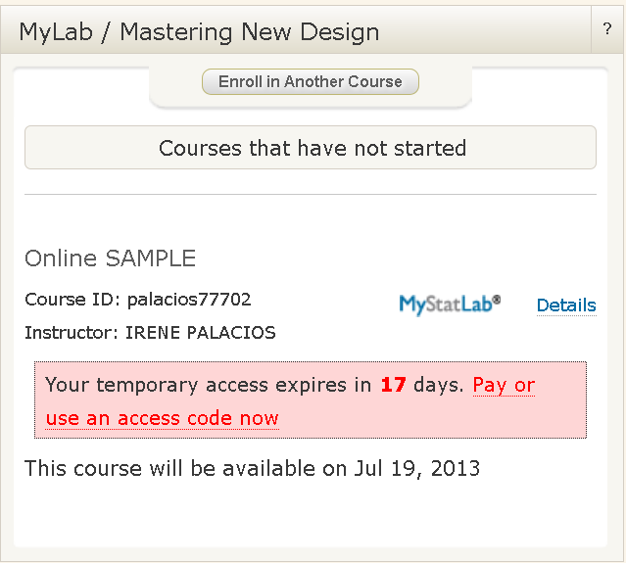
SAMPLE

